 | THE HOLY SPIRIT CATHOLIC PRIMARY SCHOOL  VIDEO GROUP CONTACT WITH CHILDREN  RISK ASSESSMENT
Location /Site |  | Insert location and site where activity taking place
THE HOLY SPIRIT CATHOLIC PRIMARY SCHOOL, COTTERILL, RUNCORN, WA7 2NL
Activity / Procedure |  | Insert name/type of activity or procedure being assessed
ZOOM MEETING WITH CLASS/SCHOOL
Assessment date |  | Insert date when assessment is being carried out
5TH January 2021

Risk Assessment Guidance

Hazard: Something with the potential to cause harm.

To Assess Risk: Using the tables below, consider Severity (S) and Likelihood (L) without Control Measures. Multiply (S x L)

Describe Control Measures: Control measure(s) reduce the likelihood, and/or severity of harm, reducing risk.

Re-assess Risk, considering Severity (S) and Likelihood (L) with Control Measures in place.
Multiply (S x L) = Risk Rating (with controls).

 | Severity (S) |  |  | Likelihood (L) |  |  | Risk Ratings (R)
 | Fatality = 5 |  |  | Likely = 5 |  |  | 20 + |  |  | High Risk
 | Injury (Specified injury / RIDDOR reportable) = 4 |  |  | Probable = 4 |  |  | 15-19 |  |  | Medium Risk
 | Injury (requiring treatment and/or 3 to 7 day |  |  | Possible = 3 |  |  | 9–14 |  |  | Low Risk
 | absence) = 3 |  |  | Possible = 3 |  |  | 9–14 |  |  | Low Risk
 | Injury (requiring treatment and/ or absence less |  |  | Unlikely = 2 |  |  | 4 – 8 |  |  | Negligible Risk
 | than 3 days) = 2 |  |  | Unlikely = 2 |  |  | 4 – 8 |  |  | Negligible Risk

Page 1 of 6

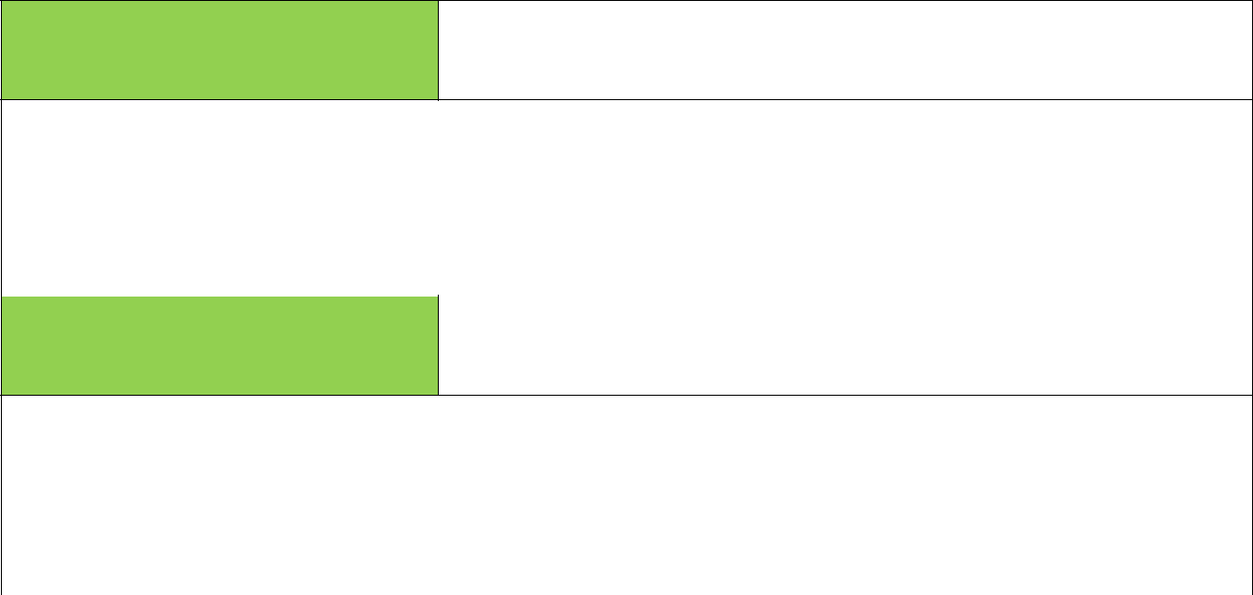

Record the hazard that could cause harm or injury – add appropriate
Identify hazard
detail about the type and location of hazards

Lack of supervision on the internet by parents

 | Existing level of risk |  | Consider current level of risk
 | HIGH | MEDIUM |  | LOW | NEGLIGIBLE

List your control measures required to reduce risk – add appropriate
Control measures
detail about the type and location of controls

- Parents ask to make themselves known to the host and asked to stay close to child for the meeting.
- Parents asked to login for the child using the two-stage authentication
 | Remaining level of risk |  | Consider level of risk following use of control measures
 | HIGH | MEDIUM |  | LOW | NEGLIGIBLE
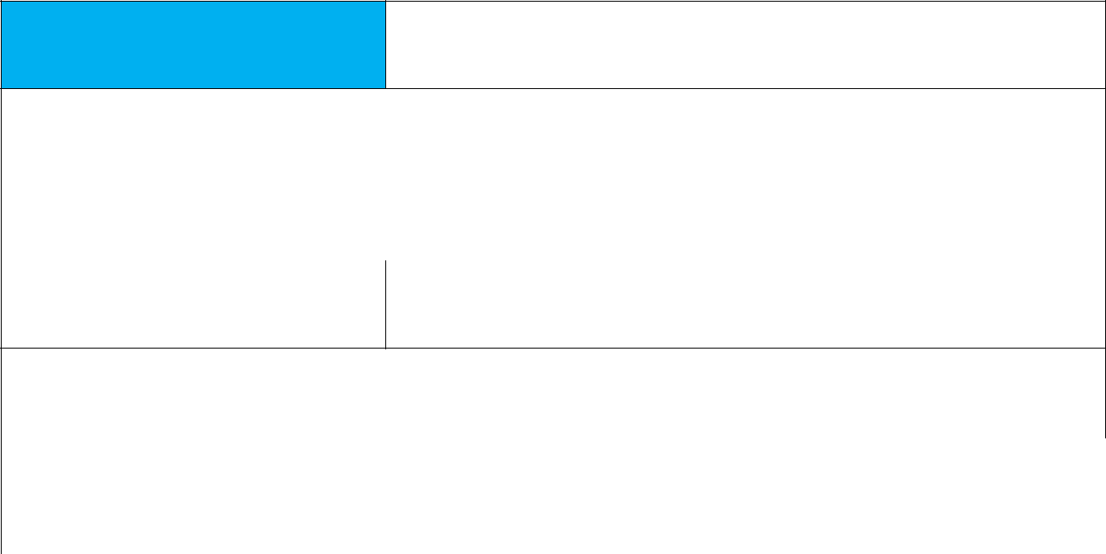

Record the hazard that could cause harm or injury – add appropriate
Identify hazard
detail about the type and location of hazards

Members of the public attending – non invited guests

 | Existing level of risk |  | Consider current level of risk
 | HIGH | MEDIUM |  | LOW | NEGLIGIBLE


List your control measures required to reduce risk – add appropriate
Control measures
detail about the type and location of controls

- Waiting room used – one attendee is accepted at a time. Parent and child must be present when in waiting room and staff verifies the child is the child we are expecting
- The meeting ID is sent via email and the PASSWORD is sent via Dojo to the parent
 | Remaining level of risk |  | Consider level of risk following use of control measures
 | HIGH | MEDIUM |  | LOW | NEGLIGIBLE


Record the hazard that could cause harm or injury – add appropriate
Identify hazard
detail about the type and location of hazards

Parents not being aware of the risks of using Zoom

 | Existing level of risk |  | Consider current level of risk
 | HIGH | MEDIUM |  | LOW | NEGLIGIBLE



List your control measures required to reduce risk – add appropriate
Control measures
detail about the type and location of controls

Page 2 of 6

- Send parental internet guide specifically concerning Zoom: https://www.saferinternet.org.uk/blog/what-%E2%80%A6-zoom-guide-parents-and-carers#How%20Zoom%20works

- Set out clear expectations for parents concerning their role in keeping the children safe.
- Parents asked to ensure children are dressed appropriately.

- Parents told to ensure meeting is taking place in public space i.e. the living room / dining room – not child’s bedroom

 | Remaining level of risk |  | Consider level of risk following use of control measures
 | HIGH | MEDIUM |  | LOW | NEGLIGIBLE
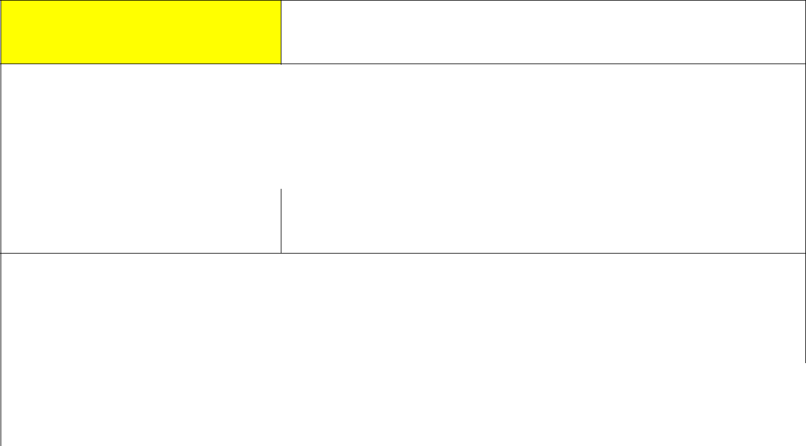

Record the hazard that could cause harm or injury – add appropriate
Identify hazard
detail about the type and location of hazards

Children acting inappropriately whilst on Zoom call

 | Existing level of risk |  | Consider current level of risk
 | HIGH | MEDIUM |  | LOW | NEGLIGIBLE


List your control measures required to reduce risk – add appropriate
Control measures
detail about the type and location of controls

- A second member of staff will be present on all class Zoom calls, alongside the host.
- Children will be muted and unmute permission removed for all users

- Parents requested to remove child from the meeting – LEAVE MEETING if child behaves inappropriately

 | Remaining level of risk |  | Consider level of risk following use of control measures
 | HIGH | MEDIUM |  | LOW | NEGLIGIBLE
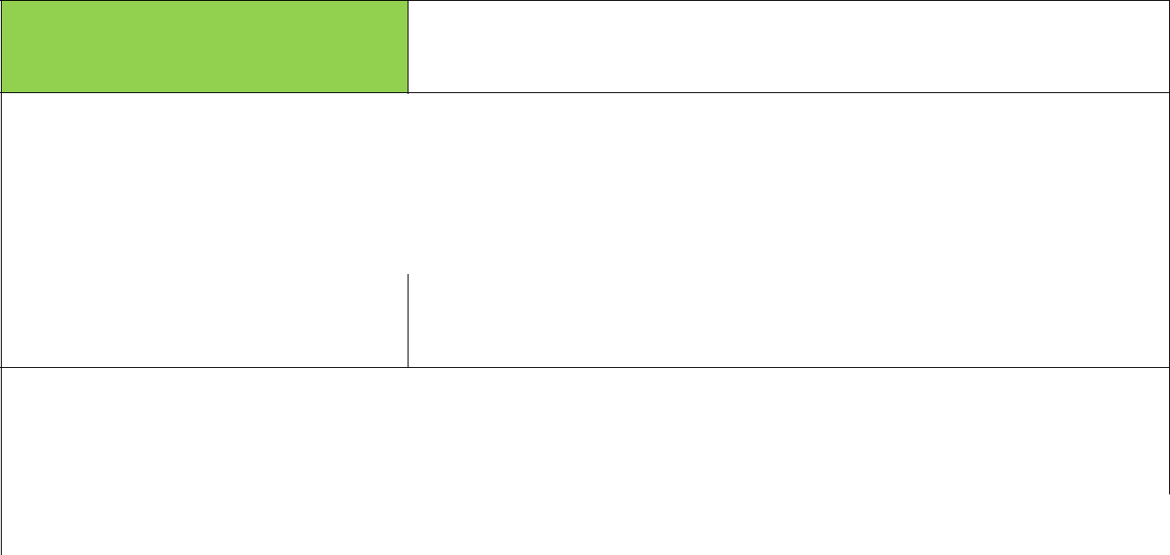

Record the hazard that could cause harm or injury – add appropriate
Identify hazard
detail about the type and location of hazards

Adult or other children acting inappropriately by accident or deliberately

 | Existing level of risk |  | Consider current level of risk
 | HIGH | MEDIUM |  | LOW | NEGLIGIBLE


List your control measures required to reduce risk – add appropriate
Control measures
detail about the type and location of controls

- A second member of staff will be present on all class Zoom calls, alongside the host.
- Children will be muted and unmute permission removed for all users
- Staff will remove any person from the meeting if the child acts inappropriately or return them to the waiting room for 5 minutes

 | Remaining level of risk | Consider level of risk following use of control measures

Page 3 of 6

THE EMMAUS FEDERATION HEALTH & SAFETY

HIGH | MEDIUM | LOW | NEGLIGIBLE
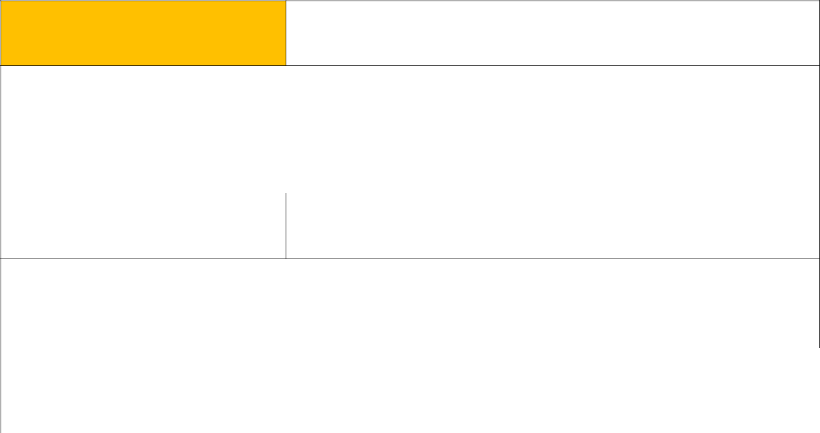

Record the hazard that could cause harm or injury – add appropriate
Identify hazard
detail about the type and location of hazards

Parents making judgement about each other’s homes

 | Existing level of risk |  | Consider current level of risk
 | HIGH | MEDIUM |  | LOW | NEGLIGIBLE


List your control measures required to reduce risk – add appropriate
Control measures
detail about the type and location of controls

- Parents given information concerning using a background – Zoom feature https://support.zoom.us/hc/en-us/articles/360034967471-Quick-start-guide-for-new-users

- Parents suggested to ensure nothing in the background they do not want others to see – blank wall https://support.zoom.us/hc/en-us/articles/210707503-Virtual-Background
 | Remaining level of risk |  | Consider level of risk following use of control measures
 | HIGH | MEDIUM |  | LOW | NEGLIGIBLE
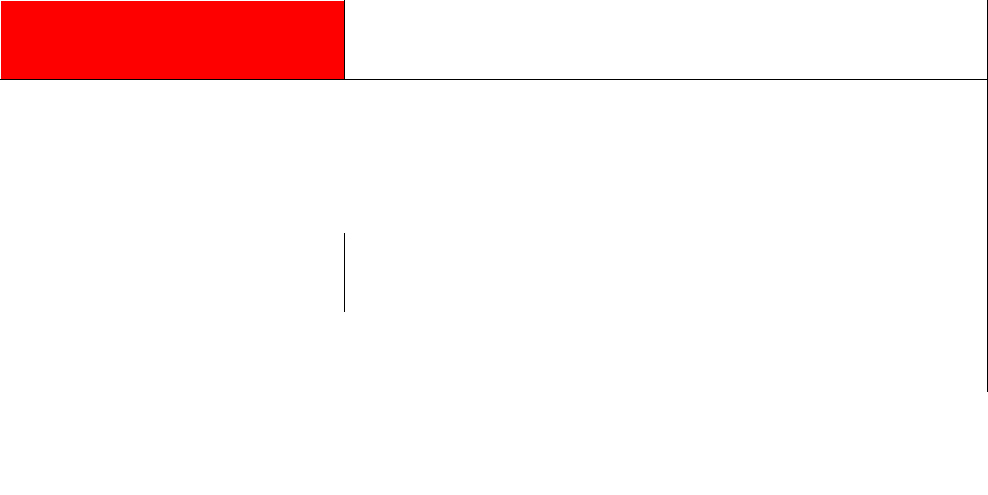

Record the hazard that could cause harm or injury – add appropriate
Identify hazard
detail about the type and location of hazards

Illegal or inappropriate content in the houses of the children

 | Existing level of risk |  | Consider current level of risk
 | HIGH | MEDIUM |  | LOW | NEGLIGIBLE


List your control measures required to reduce risk – add appropriate
Control measures
detail about the type and location of controls

- Members of staff will be the host of every meeting and will remove any family from the meeting. if this is necessary
- Check will be made when accepting children into the meeting and message sent to parent via Dojo
 | Remaining level of risk |  | Consider level of risk following use of control measures
 | HIGH | MEDIUM |  | LOW | NEGLIGIBLE


Record the hazard that could cause harm or injury – add appropriate
Identify hazard
detail about the type and location of hazards

Attendance of estranged parents on email system

 | Existing level of risk | Consider current level of risk

Page 4 of 6

THE EMMAUS FEDERATION HEALTH & SAFETY

HIGH | MEDIUM | LOW | NEGLIGIBLE

List your control measures required to reduce risk – add appropriate
Control measures
detail about the type and location of controls

1. List of estranged parents to be given to office – DSL to be consulted to create the list
 | Remaining level of risk |  |  |  |  | Consider level of risk following use of control measures
 |  | HIGH | MEDIUM |  |  |  |  |  |  | LOW |  | NEGLIGIBLE
 |  | OVERALL level of risk |  |  |  |  | Consider level of risk following use of control measures
 |  | OVERALL level of risk |  |  |  |  | HIGHLIGHT the appropriate assessment of risk
 |  | NOT REDUCED THE OVERALL RISK |  |  |  |  |  | REDUCED THE OVERALL RISK |  |  | CONSIDERABLY REDUCED THE
 |  |  |  |  |  |  |  | TO SOME DEGREE |  |  |  | RISK
 |  | Assessor’s comments |  |  |  |  | Insert comments relevant to findings as appropriate
 |  | Name of assessor |  |  |  |  | Signature of assessor |  |  |  | Date
 | Mrs Connolly |  |  |  |  |  |  | 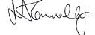 |  |  | 5th January 2021
 |  | Risk assessment review
 |  | Date: |  | After day one/week one/ on-going
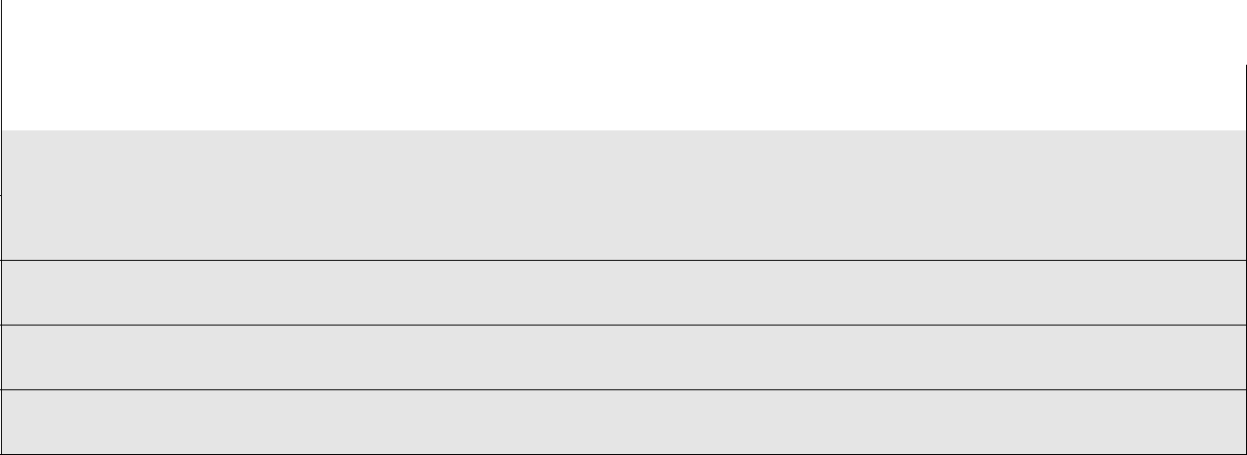

CHANGES TO CONTROLS MEASURES AND OR HAZARDS

Who was involved in the Review

Signature of those involved in the Review

Page 5 of 6

THE HOLY SPIRIT CATHOLIC PRIMARY SCHOOL

ZOOM CLASS MEETING INSTRUCTIONS AND REQUIRMENTS FOR PARENTS

- Read the following safety guide for parents concerning ZOOM https://www.saferinternet.org.uk/blog/what-%E2%80%A6-zoom-guide-parents-and-carers#How%20Zoom%20works

- Set up Zoom on your device and if using the APP ensure it has been recently updated. (please see info at end of document for more info re the APP) https://support.zoom.us/hc/en-us/articles/360034967471-Quick-start-guide-for-new-users

- Test with friends and family before using with school

- Receive the meeting details of class ZOOM meeting via Dojo

- Receive the password for class ZOOM meeting via Dojo

- Join meeting https://support.zoom.us/hc/en-us/articles/201362193-Joining-a-meeting

- Change attendees name to your child’s name – we know it is you then in the waiting room. Ensure you are present at the start of the meeting, in the same room and we will check this when your child is invited to the meeting from the WAITING ROOM

- Change the background if you can or make sure there is a blank background, or anything behind your child you are happy for all other parents to see. https://support.zoom.us/hc/en-us/articles/210707503-Virtual-Background

- Ensure your child is clothed appropriately – as they would be for a non-uniform day here in school

- Explain to your child they will be in a waiting room at first until the staff member invites them. This might take a while as each person has to be invited in one at a time and we have to check they are who they say they are. Please go onto Zoom 15 minutes before so we can admit each child. Ensure you child is present when invited from the Waiting Room and video is switched on – we will be using old style FACE RECOGNITION!

- Ensure you know how to leave the meeting so you can leave the meeting if your child starts to behave inappropriately or someone enters the shot who is not dressed appropriately or is behaving inappropriately.

- Explain to your child the staff member will be in charge of the sound for everyone and will unmute you when it is your turn to talk. They will not need to unmute themselves and they should not. Most of the time everyone but the member of staff / EHT/ HoS/ DSL or one person at a time will be muted.

Many thanks,
Mrs Connolly

Page 6 of 6

