Tuesday, 28 July 2026

Dear Parents/Carers,

Year 4 will start swimming lessons on Friday 10th January 2020 and will run for 12 sessions up until and including Friday 3rd April 2020. Your child will need a towel; girls are to have a full swim costume and not a bikini. Boys are to have swimming trunks and not swimming shorts. Goggles are allowed.

Many thanks,
Mrs Green
Class Teacher

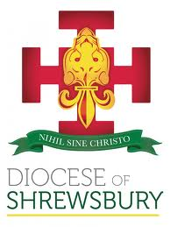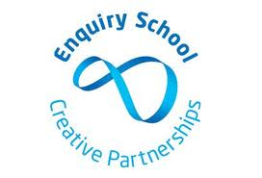

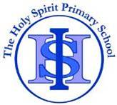
THE HOLY SPIRIT CATHOLIC
PRIMARY SCHOOL
Cotterill, Halton Brook, Runcorn, Cheshire. WA7 2NL
Tel: 01928 563148 Fax: 01928 566792
Email: sec.theholyspirit@halton-borough.gov.uk www.holyspiritruncorn.co.uk

Headteacher: Mr J McDonald BEd (Hons) NPQH

The Diocese of Shrewsbury In Partnership with Halton Borough Council

Tuesday, 28 July 2026

Dear Parents/Carers,

Year 4 will start swimming lessons on Friday 10th January 2020 and will run for 12 sessions up until and including Friday 3rd April 2020. Your child will need a towel; girls are to have a full swim costume and not a bikini. Boys are to have swimming trunks and not swimming shorts. Goggles are allowed.

Many thanks,
Mrs Green
Class Teacher

