28/07/2026

Dear Parents / Carers,

Christmas Production

The Christmas production will still go ahead on Tuesday 17th December at 10am and 2pm.

In order to comply with fire regulations we will be issuing two tickets per family per performance for this year’s Christmas production and it is for you as a family to decide who attends. Please note we are unable to provide additional tickets. Tickets have been sent home with children today.

As a precaution, we are advising vulnerable people to make the decision if they should be attending.

For most healthy people flu is an unpleasant but self-limiting illness. However, some people can be more at risk of developing severe illness or complications including the following groups:

- Those aged 65 years or over
- Pregnant women
- Those with a long-term medical condition – for example, diabetes or a heart, lung, kidney or neurological disease
- Those with a weakened immune system – for example, because of chemotherapy or HIV

Snow White and the Seven Dwarfs
We have rearranged The Brindley Pantomime to Friday 10th January 2020 at 10am. We were at risk of having to cancel due to advice from Infection Control. We didn't want any children to miss out through illness, we hope you understand.
Yours faithfully,
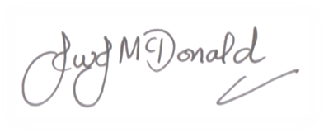

John McDonald
Headteacher

