31 July 2026

Dear Parent/Guardian,

On Friday 20th December, we will finish school at 1.30pm, please ensure you collect children on time.

There is an Inset day on Monday 6th January for staff, children start back at school on Tuesday 7th January.

Yours faithfully,

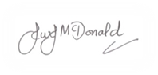
Mr J McDonald
Headteacher

