CHRISTMAS FAIR

31/07/2026

Dear Parents / Carers,

If you are coming along to the Christmas Fair tomorrow, then please be advised all children must be accompanied by an adult.

As the fair is taking place on a Saturday, staff numbers are limited. Children who are not accompanied by a parent / adult will be refused entry.

The Christmas Fair opens at 10.30am – 2.30pm, you do not need to stay for the whole of the event you can come and go as you please. Everyone is welcome, we hope you have a lovely time and can come along and support our school and PTA.

Yours sincerely
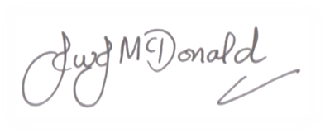

John McDonald
Headteacher

