25/11/2019

Dear Parents/Carers,

We have reviewed our arrangements for picking up the children at the end of the school day.
Children are allowed to walk home by themselves but must be in Year 5 and 6 only and must go straight home. For children up to year 4, no child will be allowed to go home with a brother or sister less than 16 years of age. (Younger siblings will not be allowed to walk home and must be picked up by an appropriate adult.) We may not release the children if we suspect the child is younger than 16.
Children from Reception to Year 4 must be collected by an adult. Staff have been instructed to only let the children go if they have made eye contact with the adult and this is a walk of a few metres, watching the children to the adult. Please do not wait at the gate or the ramp. We hope that you will be patient with us at the end of the day and I would ask all parents to ensure that you leave room by the back door. We will dismiss as quickly as we can but safety is our priority.

To help us ensure your child’s safety each day, please would you complete the attached reply slip and return it to your child’s teacher. As long as we have their name on your authorised list it will also save you some time ringing in on days when another person is collecting them from school.

Many thanks,
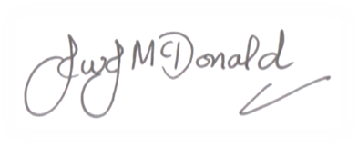
Mr J McDonald
Headteacher

Parent Authorisation Reply Slip

Child’s Name ______________________________________ Year Group _____________________
Is allowed to be collected from school by the following people:

Name and Relationship __________________________ Phone Number _______________________

Name and Relationship __________________________ Phone Number _______________________

Name and Relationship __________________________ Phone Number _______________________

Name and Relationship __________________________ Phone Number _______________________

Signed ___________________________ Date _______________________

Relationship to child __________________________

