Friday, 31 July 2026

Dear Parents and Carers,
We have had a confirmed case of head lice in year 1/2. Can you please check your child’s hair. It is advised to use specialist shampoo to treat the head lice to prevent them spreading which can be obtained from care at the chemist free of charge.

NHS Care at the Chemist
Care at the Chemist (also known as the Minor Ailments Scheme) is a scheme that allows you to get medicines and advice for certain illnesses from your local pharmacy without having to go to your GP first. This means you don’t have to wait for an appointment – you can get expert advice whenever the chemist is open, without having to wait for an appointment.
Patients who are over the age of two, are registered with a doctor taking part in the Minor Ailments Service, and are suffering from a minor illness included in the local service can use the scheme.
Examples of minor illnesses that may be included are:
- Allergies
- Athlete’s foot
- Back ache, sprains and strains
- Coughs, colds and sore throats
- Cold sores
- Constipation
- Cystitis
- Diarrhoea
- Ear Wax Removal
- Headache
- Pain or temperature
- Haemorrhoids
- Head lice
- Indigestion
- Mouth ulcers
- Minor eye infections
- Minor skin reactions
- Nasal congestion
- Oral thrush
- Threadworm
- Thrush (genital)
- Warts and verrucas
Many thanks,
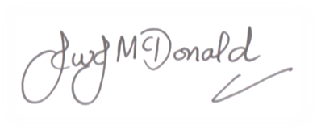
Mr J McDonald
Headteacher

