Thursday, 30 July 2026

Dear Parents and Carers,

As the weather gets hotter, please ensure that your child comes to school with a hat and sunscreen already applied as we are not allowed to apply sunscreen to children in school.
School has supplied each child with their own water bottle to make sure they stay hydrated throughout the warmer months.

Some people such as young children are more vulnerable to the effects of heat which can impact on health.

Thank you for your continued support.

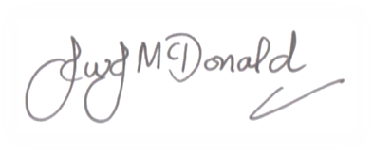
Mr J McDonald
Headteacher

