Friday, 22 February 2019
Breakfast Club

Dear Parents and Guardians,

I wanted to let you know that from week beginning 4th March we are going to change the way we run the Computer Club.

The Computer Club will become a more formal breakfast Club – still starting at 8.15am. For those eligible for free school meals the Club will be free and for those not there will be a charge of £1 a day. The places are limited so if you want to take this offer up please respond to the slip below on a first come first served basis. Priority will be given to those that already use the Computer club. The £1 is great value considering other clubs that operate like this are charging an average of £3 a day. Ours will only be £1.

There will be no need to line up in the morning for all children– the doors will open at 8.45am (like we do when it rains) and the teachers will be in class. We hope that this gives us an even smoother start to the day. Learning will be able to start promptly from 8.55. In conjunction with magic breakfast a Bagel will be available to eat from this time for all children and will be available in the classrooms up until 8.55am. We hope to encourage the children to do a little bit of extra reading / time tables and they can enjoy a tasty snack at the same time.

Please respond to the letter so that we can plan appropriately. As always your help and support is appreciated.
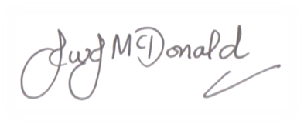
Mr J McDonald

+++++++++++++++++++++++++++++++++++++++++++++++++++++++++++++++

I would like my son/daughter _________________ Class ______ to come to the Breakfast club each morning. They do / do not already use computer club on a daily basis.

I will / will not be able to pay £1 each morning / weekly.

Signature ____________________________

