Tuesday, 28 July 2026

Dear Parents/Guardians,

We would like to emphasise the importance of supporting school trips. We try our best to provide school trips throughout the year for different classes but we really need parents to help with contributions to the trip. With regards to the recent trips we have recently organised we still have a few parents who have not contributed yet. This potentially could mean that we have to ask for money to be paid in full before we can see if a trip is viable. If the money does not come in - we would need to cancel the trip in advance. This is something I really do not want to do.
These are voluntary contributions but we do try to keep costs to a minimum. Without your voluntary contribution it does make it hard to see how we can do more trips in the future and we do want to do more trips – I hope you understand.

We would like to ask all parents/guardians to leave prams outside of school and children to be carried in on the days of the Nativity. The Nativity is a ticket only event due to fire regulations, please bring your ticket to the performance for entry.

Many thanks for your understanding.

Yours sincerely,
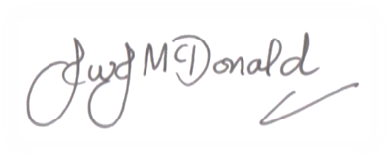

John McDonald
Headteacher

