Friday, 31 July 2026

Nativity Play
Dear Parents,

This year’s nativity play will be `Angel Express’ there will be two performances which will be held in the school hall on Monday 17th December at 2pm and Tuesday 18th December at 2pm.

We have to limit numbers due to fire regulations and numbers of people allowed in the Hall. On this note, we will be issuing 2 tickets per child for each performance. Please can we ask that all push chairs & prams be left in the front entrance. No one will be allowed entry without a ticket, so please do not lose them – we cannot replace them. If you don`t need all of your tickets, please can you return them to school a.s.a.p. Anyone hoping for more tickets can leave their name at the office and we will give these out on a first come first served basis on Friday 14th December.

We would like to ask you only watch one performance as this will ensure everyone has the chance to watch their child/children.

Please tick below which day you would like tickets for and return to the school office.

Thank you for you co-operation in this!
Yours sincerely,
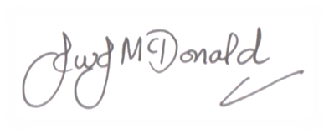

John McDonald
Headteacher
………………………………………………………………………………………………………
`Angel Express’ Nativity Play

Child Name: ………………………….. Class: …………………..

I would like 2 tickets for Monday 17th December at 2pm

I would like 2 tickets for Tuesday 18th December at 2pm

