Tuesday, 28 July 2026

Dear Parent/Carer
Enhancing safety in our school - Invacuation
At The Holy Spirit, we take safeguarding and safety very seriously. It is important that we continue to review all our procedures, taking into account even those events that are very unlikely to occur. As part of this process, we have introduced a new procedure called “invacuation”.
What is an invacuation and when would we carry it out?
An invacuation procedure is a standard health and safety procedure, similar to a fire drill.
Our lockdown procedure would be used when there is a threat to the safety of pupils, staff and others in the school, and when it is safer for everyone to remain in school than evacuate. The aim is to keep people safe by confining them to a secure place of safety.
Situations where our invacuation procedure may be used include:
• A potentially dangerous person or animal on the school site
• A disturbance or dangerous situation in the local community that could affect the school
• A nearby chemical incident or other risk of air pollution
• An incident related to terrorism
Our procedure:
We have two types of invacuation;
Partial invacuation – when staff are asked to secure all doors and windows and children are asked to remain quietly in their seats.
Full invacuation – when staff are asked to secure all doors, windows and blinds. Children are asked to move to a safe area.
I am writing to inform you that we will be practising a partial invacuation on Friday 14th December.
Prior to our drill, staff will take time to talk to pupils about invacuation procedures and explain why they are important. They will reassure pupils after the drill that they are safe, and will emphasise that practising procedures like this will make sure the school remains a safe place to learn. Children currently practice fire drills as a precaution and we would like the invacuation procedure to be as calm and normal for our pupils as our fire bell.
I must stress again this is simply a practice, so that in the unlikely event of such a situation, our pupils and staff are fully prepared.
If you or your child have any further concerns or questions, please do not hesitate to contact Mrs Connolly or myself.
Many thanks,
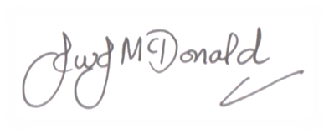
Mr J McDonald
Headteacher

