Thursday, 30 July 2026

Dear Parents/Guardians,

Mini Police

The Mini Police in Year 6 have some special visitors coming into school tomorrow. They will be meeting with the PCC, Police and Crime Commissioner for Cheshire and councillors from Halton Borough Council.

Photographs will be taken throughout the morning and will be displayed in school but also externally on Twitter etc.

If you do not wish your child to be photographed, please complete the reply slip below and return to school tomorrow morning.

Many thanks,

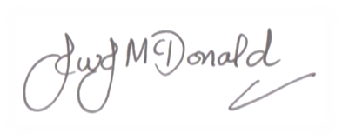

Mr J McDonald
Headteacher

Mini Police

I do not give permission for _________________ to have photographs taken.

Signed: _________________________ Emergency Contact Number: _________________________
Date: _______________________

