Thursday, 30 July 2026

Dear Parents/Guardians,

We will be having a non-uniform day on Friday 30th November to raise prizes for the Christmas Bingo. We are asking for donations of chocolates, wine, biscuits or selection boxes.
We really appreciate your support as always.

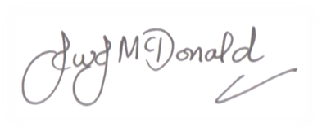
Many thanks,

Mr J McDonald
Headteacher
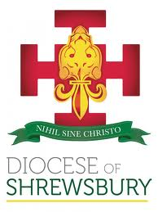

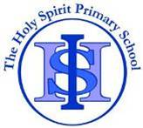
THE HOLY SPIRIT CATHOLIC
PRIMARY SCHOOL
Cotterill, Halton Brook, Runcorn, Cheshire. WA7 2NL
Tel: 01928 563148 Fax: 01928 566792
Email: sec.theholyspirit@halton-borough.gov.uk www.holyspiritruncorn.co.uk

Headteacher: Mr J McDonald BEd (Hons) NPQH

The Diocese of Shrewsbury In Partnership with Halton Borough Council
Thursday, 30 July 2026

Dear Parents/Guardians,

We will be having a non-uniform day on Friday 30th November to raise prizes for the Christmas Bingo. We are asking for donations of chocolates, wine, biscuits or selection boxes.

We really appreciate your support as always.

Many thanks,

Mr J McDonald
Headteacher

