Friday, 31 July 2026

Dear Parents/Carers,

On Friday 12th October we will be supporting CAFOD and are asking children to come into school wearing their own clothes and £1.00 donation.

As always your help and support is very much appreciated.

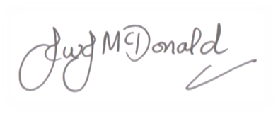
Many thanks,

Mr J McDonald
Headteacher
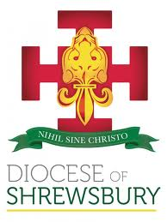

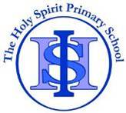
THE HOLY SPIRIT CATHOLIC
PRIMARY SCHOOL
Cotterill, Halton Brook, Runcorn, Cheshire. WA7 2NL
Tel: 01928 563148 Fax: 01928 566792
Email: sec.theholyspirit@halton-borough.gov.uk www.holyspiritruncorn.co.uk

Headteacher: Mr J McDonald BEd (Hons) NPQH

The Diocese of Shrewsbury In Partnership with Halton Borough Council
Friday, 31 July 2026

Dear Parents/Carers,

On Friday 12th October we will be supporting CAFOD and are asking children to come into school wearing their own clothes and £1.00 donation.

As always your help and support is very much appreciated.

Many thanks,

Mr J McDonald
Headteacher

