Cycle A Summer Term Year 1/2 History Knowledge Organiser
Main Learning
Who were some of the great explorers of the world?

Key Vocabulary
Achievement | An achievement is something challenging that a person does well.
Equipment | Objects that are needed for an activity, such as exploring.
Expedition | A journey taken for a reason, such as exploring somewhere or something.
Explorer | Someone who goes on a journey to find out about somewhere or something new.
Significant | Important and worth knowing about.
Voyage | A long journey involving travel by sea or in space.
Discovery | to find or see before anyone else.
Astronaut | An astronaut is a person who is specially trained to travel in outer space

hot
(Sticky) Knowledge & Skills that I need to remember
- I can compare life when Ibn Battuta travelled to life today.

- I can compare the life of Ibn Battuta to Christopher Columbus and explain why they are significant

- I can say what life was like for Christopher Columbus and why is he significant.

- I can say what Christopher Columbus discovered and some of the key events from his expedition

- I can say the differences and similarities between the lives of Christopher Columbus and Ibn Battuta

- I Can research and ask questions

- I can say the differences and similarities between the lives of Neil Armstrong and Sunita Williams.

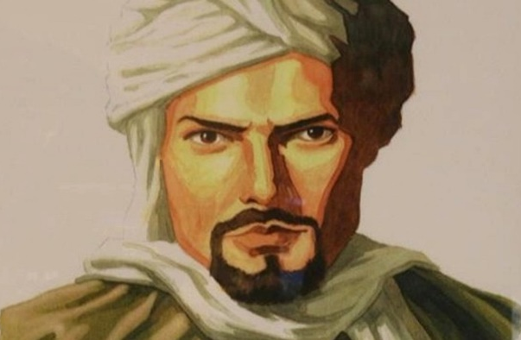
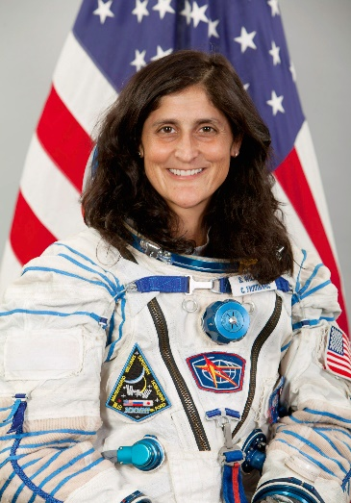

History Quiz 1
Name ………………………….

 | Question | A | B | C
1 | What is an explorer? | Someone who goes on a journey to find out about somewhere or something new. | Someone who makes sure people follow the laws and protect people from harm | Someone who puts out fires
2 | Sunita Williams is an… | Astronaut | Olympic gold medallist | Pilot
3 | What did Christopher Columbus discover? | He discovered new lands called the Americas | He was the first man to land on the moon | He climbed the world’s largest mountain
4 | An expedition is… | A journey taken for a reason, such as exploring somewhere or something. | A hard test in high school | Where animals live
5 | What does the word significant mean? | Important and worth knowing about. | A long journey involving travel by sea or in space. | Objects that are needed for an activity, such as exploring.
6 | Neill Armstrong was… | …was the first man to walk on the moon | …was the first man to fly a plane | …was the first man to discover the world is not flat

Total
Prior knowledge % | 1st Attempt % | 2nd attempt % | 3rd Attempt %

What else have you Learned
(optional)

