Cycle A Summer Term Year 3/4 History Knowledge Organiser
Key Vocabulary
Invade | Enter a place or land with the intention of occupying it.
Empire | An extensive group of states or countries ruled over by a single monarch.
conquer | To overcome and take control of people or land using military force
trade | Trade is the buying and selling of goods and services
agriculture | Farming. It includes both growing and harvesting crops and raising animals or livestock.
legion | A large section of the Roman army made up of 4000 – 6000 soldiers
emperor | The Roman emperor was the ruler  of the Roman Empire during the imperial period
armour | any kind of clothing that is intended to protect the wearer in combat
Natural resources | A natural resource is something that is found in nature and can be used by people.

(Sticky) Knowledge & Skills that I need to remember
- I can show events on a chronological Timeline relating to my past understanding of historical periods.
- I can say what Britain was like in 55 B.C. and why the Romans wanted to invade Britain
- I can understand why the Roman Empire were so successful.
- I can say whether it was easy for the Romans to invade and explain the reasons, using evidence.
- I can explain the spread of the Roman empire
Main Learning
(Sticky) Knowledge & Skills that I need to remember

- I can show events on a chronological Timeline relating to my past understanding of historical periods.
- I can say what Britain was like in 55 B.C. and why the Romans wanted to invade Britain
- I can understand why the Roman Empire were so successful.
- I can say whether it was easy for the Romans to invade and explain the reasons, using evidence.
- I can explain the spread of the Roman empire

Where and how did the Roman Empire spread?

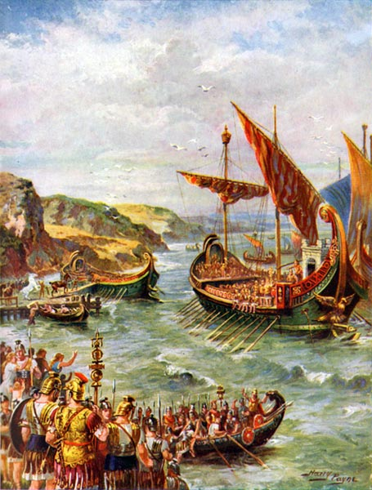
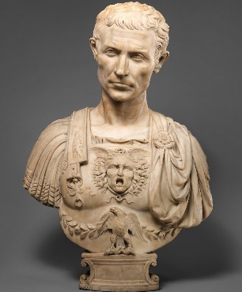

History Quiz 1
Name ………………………….
 | Question | A | B | C
1 | The first emperor to invade Britain in 43 AD was… | Claudius | Hadirian | Caesar
2 | Who invaded Britain twice in 55 BC and 54 BC? | Julius Caesar | Julius Hadrian | Gladiators
3 | What is the name of people who lived in Britain when the Romans invaded? | Celts | Colts | Calts
4 | What was the name of the wall that was built all the way across Britain? | Hadrian’s Wall | Hadrian’s Fort | Caesar’s Wall
5 | Why did the Romans invaded Britain? | Lots of resources | The Celts annoyed them | It was easy
6 | What does the word ‘legion’ mean? | A large section of the Roman army made up of 4000 – 6000 soldiers | Enter a place or land with the intention of occupying it. | The ruler of the Roman Empire during the imperial period
7 | What does the word ‘emperor mean? | The ruler of the Roman Empire during the imperial period | A large section of the Roman army made up of 4000 – 6000 soldiers | Enter a place or land with the intention of occupying it.
8 | On a timeline was does BC stand for? | Before Christ | Before Clocks | Before Celts
Total
Prior knowledge % | 1st Attempt % | 2nd attempt % | 3rd Attempt %

What else have you Learned
(optional)

