 Cycle A Summer Term Year 5/6 History Knowledge Organiser

|  |  |
| --- | --- |
| Key Vocabulary | |
| Evolution | process of change that takes place over many generations, species slowly change some of their physical characteristics |
| Inheritance | passing on characteristics from parents to offspring |
| Adaptation | a change to suit a particular environment |
| legacy | Something that is handed down from a period of time to another period of time. |
| Natural selection | most beneficial characteristics get passed on to later generations |
| Variation | a change or slight difference |
| Primary source | They are immediate, first-hand accounts of a topic from people who had a direct connection with it. |
| Ancestors | an early type of animal or plant from which a later, usually dissimilar, type has evolved |
| Secondary source | They are created by someone who did not experience it first hand or participate in the events or conditions. |
| voyage | A long journey involving travel  by sea or in space. |

Main Learning

(Sticky) Knowledge & Skills that I need to remember

|  |
| --- |
| * I know who Charles Darwin is and can identify the era in which he lived |
| * I understand that Charles Darwin’s theories were developed during a 5 year voyage. |
| * I can explain how primary evidence informs us about Darwin’s discoveries. |
| * I can describe how the theory of evolution helped to shape today’s world. |
| * I can explain how the Church was affected by Darwin’s discoveries. |
| * I can explain the legacy that Darwin left behind. |

**What did Darwin discover?**

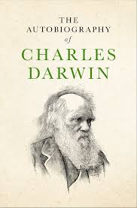

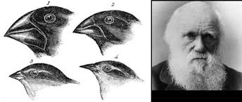

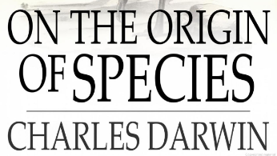

 History Quiz 1

Name ………………………….

|  |  |  |  |  |
| --- | --- | --- | --- | --- |
|  | **Question** | A | B | C |
| 1 | What did Charles Darwin research? | Studied who is the cleverest species | Studied how habitats are built and who lives in these environments | Studied plants and animal species, which allowed him to see how adaptation works |
| 2 | Where would you find evolution? | Just in plants | In all species of plants, animals, humans and insects | In computer games |
| 3 | What is adaptation? | Changing your clothes each day | Writing about insects and labelling pictures. | A change to suit a particular environment |
| 4 | Primary source is______. | They are immediate, first-hand accounts of a topic from people who had a direct connection with it. | They are created by someone who did not experience it first hand or participate in the events or conditions. | It is a process by which energy or a particular component enters a system. |
| 5 | Legacy means_______ | Is something that is handed down from one period of time to another period of time. | In or according to the order of time | A place in roman Britain |
| 6 | What is natural selection? | How animal species continue and survive. It is when organisms are best suited to their environment survive and pass on their genetics | The choice of the best entertainment, housing, clothing | How parents choose their offspring, selecting only the best mini version of them |
| 7 | Charles Darwin’s theories were developed during a _________. | 5 year voyage | 10 year voyage | 30 year voyage |
| 8 | Charles Darwin lived in the _______. | Victorian era | Second Elizabethan era | World War II era |
| 9 | The churches initial response to the Darwin’s theory was… | Negative | Positive | It didn’t matter |

Total

|  |  |  |  |
| --- | --- | --- | --- |
| Prior knowledge % | 1st Attempt % | 2nd attempt % | 3rd Attempt % |

What else have you Learned

|  |
| --- |
|  |
|  |
|  |
|  |
|  |
|  |
|  |
|  |

(optional)