Cycle A Autumn Term Year 3/4 History Knowledge Organiser
Key Vocabulary
Artefacts | Is anything made, used, or modified by humans.
Ancient | Belonging to the very distant past generally thousands of years ago.
Civilisation | The society, culture, and way of life of a particular area
Democracy | The idea that every free person gets a vote and their opinion will be heard.
contemporary | Contemporary architecture refers to the current style of architecture.
architecture | The science and art of designing buildings is known as architecture.
Monarchy | Ruled by a kings or a queen
Column | A key feature in Greek architecture that has since been copied worldwide.
Myths | The stories that the Ancient Greeks told about their gods. They often explained events or gave reasons for things happening in the world.
Sparta | A famous city state that focussed on a strong military and total discipline.
Athens | The centre of the Ancient Greek world which went on to become the capital of modern Greece.
City state | Greece was split into separate groups called city states. They made their own rules, had their own laws and often clashed with each other

(Sticky) Knowledge & Skills that I need to remember
- To find out when and where the Ancient Greeks lived

- I can use primary and secondary sources to infer information about Ancient Greece
- I can recognise the similarities and differences between life in Ancient Greece and today
- I can explain how democracy in Ancient Athens is different from that in the UK today
- I can compare the ancient Olympic Games to the modern Olympic Games
- I can identify the similarities and differences between Ancient Greek and contemporary architecture

Main Learning
How did the Ancient Greeks influence the Western world?

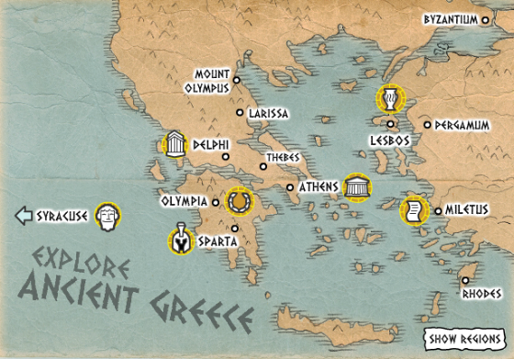
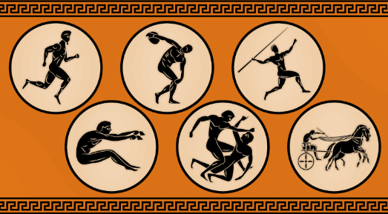

History Quiz 1
Name ………………………….
 | Question | A | B | C
1 | Where did the Ancient Greeks live? | Mostly mainland Greece and the Greek islands | China | Saudi Arabia
2 | When did the earliest Greek civilisations first appear? | 1000 years ago | 4000 years ago | 200 years ago
3 | What is similar between how to Ancient Greeks lived and today? | Went to the theatre | Worked in factories | Living in mud houses
4 | What is different between how to Ancient Greeks lived and today? | Some people worked as farmers | Went to the theatre | Ancient Greece was made up of many independent city-states.
5 | What does architecture mean? | Painting a building | Designing buildings | Taking pictures of buildings
6 | Which of these architectures were started by Ancient Greece? | ionic | Flats | Slate roof
7 | Which option is classed as contemporary architecture? | 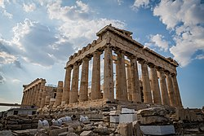 | 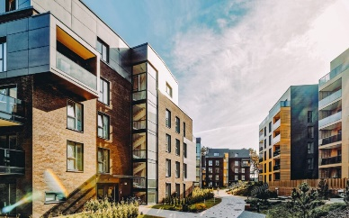 | 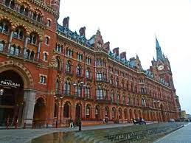
8 | Which ancient Olympic Games to are similar to the modern Olympic Games? | Long jump | Skateboarding | Surfing
Total
Prior knowledge % | 1st Attempt % | 2nd attempt % | 3rd Attempt %

What else have you Learned
(optional)

