

Cycle A Autumn Term Year 5/6 History Knowledge Organiser

|  |  |
| --- | --- |
| Key Vocabulary | |
| Settlement | Where people live and sometimes work. |
| migration | The movement of people from one place to another. |
| trade | The buying and selling of goods and services. |
| The Windrush Generation | A term used to describe people who moved from the Caribbean to Britain between 1948 to 1971. |
| immigration | the process of moving to a new country, with plans to live there permanently |
| emigration | The act of leaving one’s own country to settle permanently in another; moving abroad. |
| discrimination | treating some people differently from others |
| culture | The traditions and beliefs that groups of people practice in their daily lives |

(Sticky) Knowledge & Skills that I need to remember

|  |  |
| --- | --- |
| * I can explain who the earliest people to migrate to Britain were | * I understand that different civilizations were developing at the same time and where they first appeared. |
| * I can explain why the Romans, Anglo Saxons and The Vikings invaded Britain | * I can identify the major achievements of the Ancient Civilizations |
| * I can explain how trade affected migration to the UK. | * I can use images of artefacts |
| * I can explain the impact WWII had on migration to Britain | * I can say how pyramids could have been built using evidence. |
| * I can explain the wind rush. | * I can explain the greatest achievements of the Ancient Egyptians. |
| * I can explain recent migration to the UK. | * I can learn about ancient beliefs in different civilizations |

Main Learning

**How did migration change over time?**

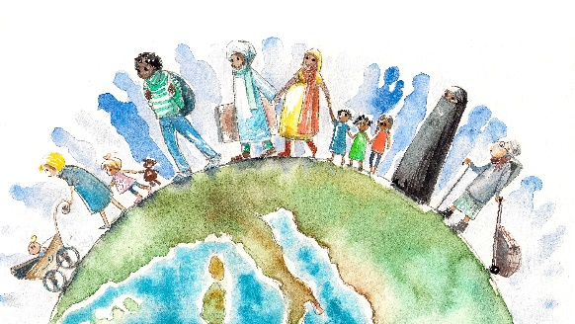

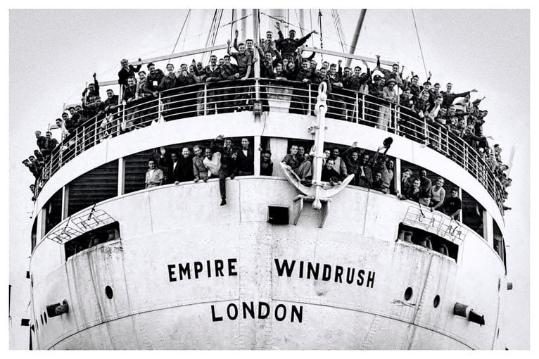

 History Quiz 1

Name ………………………….

|  |  |  |  |  |
| --- | --- | --- | --- | --- |
|  | **Question** | A | B | C |
| 1 | What does migration mean? | The traditions and beliefs that groups of people practice in their daily lives | The movement of people from one place to another. | Where people live and sometimes work. |
| 2 | Who invaded Britain? | Vikings | The Mayan | Victorians |
| 3 | Why did the Anglo Saxons come to Britain? | They were invited | They accidently came across Britain | For better ships |
| 4 | During WWII, why did people come to Britain? | Jobs | Family | Sanctuary |
| 5 | How did trade effect migration to the UK? | More jobs available | Better water access | More land |
| 6 | Where did people from the Windrush Generation come from? | Asia | Caribbean | England |
| 7 | When did WW2 begin? | 1939 | 1914 | 1066 |
| 8 | Vikings were known for… | Horses | Farming | longships |

Total

|  |  |  |  |
| --- | --- | --- | --- |
| Prior knowledge % | 1st Attempt % | 2nd attempt % | 3rd Attempt % |

What else have you Learned

|  |
| --- |
|  |
|  |
|  |
|  |
|  |
|  |
|  |
|  |

(optional)