 Cycle A Autumn Term Year 1/2 History Knowledge Organiser

Main Learning

**How did aeroplanes change the world?**

|  |  |
| --- | --- |
| Key Vocabulary | |
| Aircraft | A vehicle that is able to fly by gaining support from the air. |
| Engine | a machine that produces motion or power for doing work |
| aviation | the flying or operating of aircraft |
| invention | Something new that has been created by someone. |
| Hot air balloon | a large balloon that is filled with heated air and that floats in the sky |
| legacy | Something that is left behind from the past |
| pilot | a person who is qualified to fly an aircraft or spacecraft. |
| gliders | aeroplanes with no engine |
| propeller | a device with blades that move around to push against air or water |
| Chronology | Past events that are in the order that they happened from oldest to newest. A timeline shows their chronology. |

hot

(Sticky) Knowledge & Skills that I need to remember

|  |
| --- |
| * I know what life was like before aeroplanes were invented. |
| * I can find out different ways people tried to fly before the invention of aeroplanes |
| * I can find out about who the Wright brothers were and know why they are significant |
| * I can recall when the first flight was |
| * I can explain how aeroplanes have contributed to the world today |

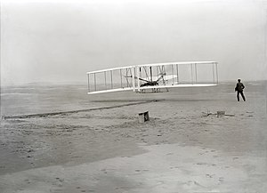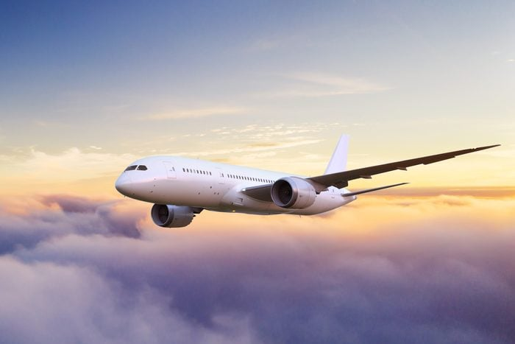

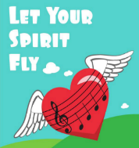 History Quiz 1

Name ………………………….

|  |  |  |  |  |
| --- | --- | --- | --- | --- |
|  | **Question** | A | B | C |
| 1 | What was the first invention that was able to take people in the air? | Aeroplane | Hot air balloon | Helicopter |
| 2 | When did the first flight take place? | 1903 | 1930 | 1805 |
| 3 | How did people travel before aeroplanes and cars were invented? | tractors | Horse-drawn carriages | Donkeys |
| 4 | How did people try to fly before the invention of aeroplanes? | jumping | trampolines | ornithopters |
| 5 | Who completed the world's first successful powered flight? | The Wright Brothers | the Montgolfier brothers | Neil Armstrong |
| 6 | What is a glider? | A helicopter | A bird | An aeroplane with no engine |

Total

|  |  |  |  |
| --- | --- | --- | --- |
| Prior knowledge % | 1st Attempt % | 2nd attempt % | 3rd Attempt % |

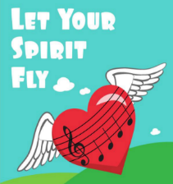What else have you Learned

|  |
| --- |
|  |
|  |
|  |
|  |
|  |
|  |
|  |
|  |

(optional)