 Cycle A Autumn Term Year 1/2 History Knowledge Organiser

Main Learning

**How has our school changed within living memory?**

|  |  |
| --- | --- |
| Key Vocabulary | |
| after | Later in time than, or behind in order |
| before | At an earlier time, in the past. |
| old | Having existed for many years; not new. |
| new | Having recently arrived, been produced or come into being. |
| past | Having happened or gone by at an earlier time |
| present | Existing at this time |
| century | One hundred years |
| chronology | The order of events in time |
| Similarity | likeness |
| Difference | The condition of being different from or not like something or someone else. |

(Sticky) Knowledge & Skills that I need to remember

|  |
| --- |
| * I can learn about The History of the Holy Spirit School and the community of Halton Brook. |
| * I can recall when it was it first built. |
| * I can find out about when the School Fire was and when was rebuilt. |
| * I can find out what different games my grandparents used to play. |
| * I can compare how our school has changed today from the time of my parents and grandparents. |
| * I can understand a simple timeline to show when events happened in our local area. |
| * I can place pictures of significant places, people, events, in chronological order. |

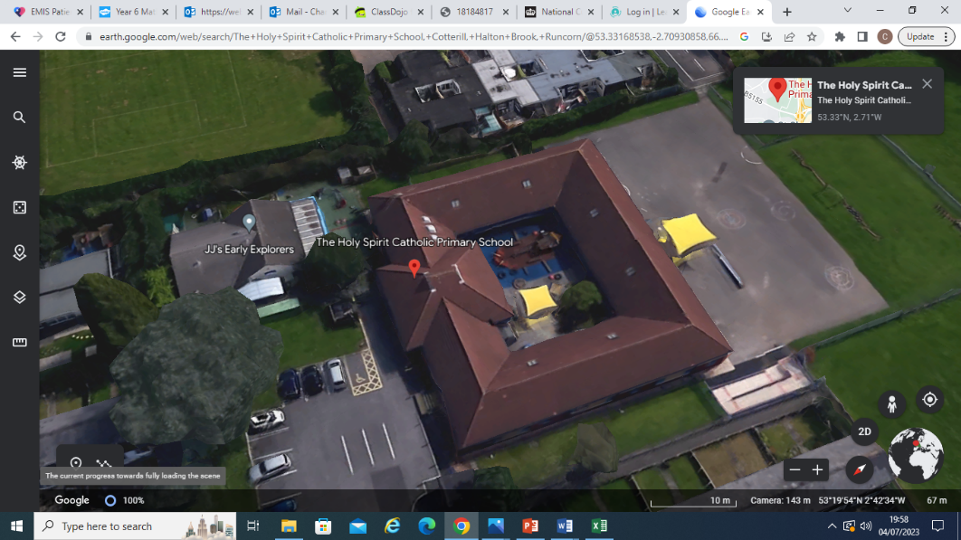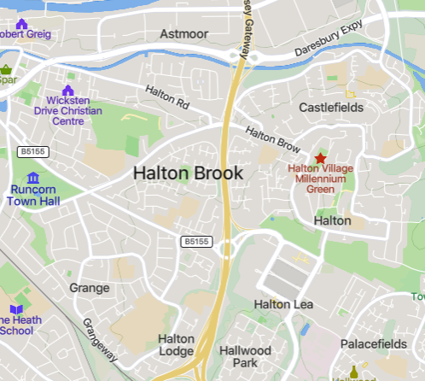

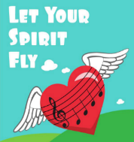 History Quiz 1

Name ………………………….

|  |  |  |  |  |
| --- | --- | --- | --- | --- |
|  | **Question** | A | B | C |
| 1 | When was The Holy Spirit first built? | 1760 | 2000 |  |
| 2 | When did the fire happen at The Holy Spirit? | 2018 | A | 1560 |
| 3 | Following the fire, when did the school get rebuilt? | 1996 | 2015 | 1650 |
| 4 | Which games might your grandparents have played? | Hopscotch | Timetable Rock stars | Minecraft |
| 5 | Why was Halton Brook estate built? | 1967 | 1980 | 1870 |
| 6 | How has the school changed today from the time of my parents and grandparents? | The hall | ICT suite | Headteacher’s office |

Total

|  |  |  |  |
| --- | --- | --- | --- |
| Prior knowledge % | 1st Attempt % | 2nd attempt % | 3rd Attempt % |

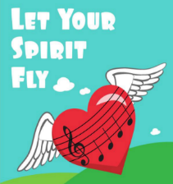What else have you Learned

|  |
| --- |
|  |
|  |
|  |
|  |
|  |
|  |
|  |
|  |

(optional)