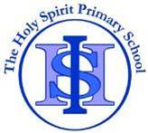 Cycle A Autumn Term Year 5/6 History Knowledge Organiser

|  |  |
| --- | --- |
| Key Vocabulary | |
| Transportation | A general word for all the methods people use to move themselves and their goods from one place to  another. |
| The Industrial Revolution | A time when the manufacturing of goods moved from small shops and homes to large factories. |
| efficiency | Operating or working in a way that  gets results, with little wasted effort. |
| developments | A process that creates growth, progress, positive change or the addition of physical, economic, environmental, social and  demographic components. |
| community | A group of people living in the same place or having particular  characteristic in common. |
| invention | The process of creating  something that has never been made before |
| manufacture | the process of turning raw materials  or parts into finished goods |

Main Learning

**Why is the history of transport so important in our local area?**

(Sticky) Knowledge & Skills that I need to remember

|  |  |
| --- | --- |
| * I can explain the different kinds of transport there have been in Runcorn. | * I understand that different civilizations were developing at the same time and where they first appeared. |
| * I can explain the challenges people in the past have had when using transport. | * I can identify the major achievements of the Ancient Civilizations |
| * I can understand how early transport held back developments in Runcorn. | * I can use images of artefacts |
| * I can understand how local people reacted to the Runcorn Bridge. | * I can say how pyramids could have been built using evidence. |
| * I can explain the difference these improvements in transport made to Runcorn. | * I can explain the greatest achievements of the Ancient Egyptians. |
| * I can explain why changes occur in the order they did. | * I can learn about ancient beliefs in different civilizations |
| * I can explain how far this transport continues to benefit the local community. |  |

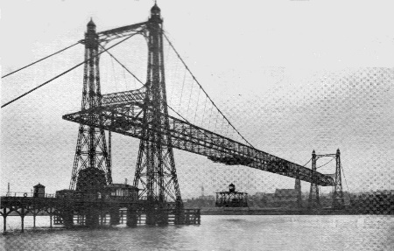

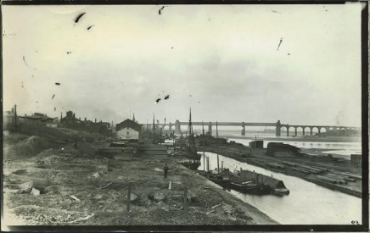

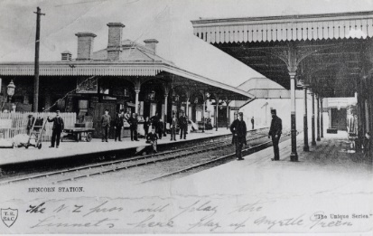

 History Quiz 1

Name ………………………….

|  |  |  |  |  |
| --- | --- | --- | --- | --- |
|  | **Question** | A | B | C |
| 1 | When did humans learn to domesticate animals and, use them for transport? | 4000BC | 1000 AD | 2000BC |
| 2 | Which modes of transport were developed to aid The Industrial Revolution? | Aeroplane and tanks | Canals and Railway | Cars and Roads |
| 3 | Which canals run through Runcorn? | Bridgewater and The Manchester Ship Canal | Leeds and Liverpool Canal | Trent and Mersey Canal |
| 4 | What was the first modes of transport? | Bicycle | Walking and Horses | Steam engine trains and ships |
| 5 | How does transport developments benefit the local community? | More jobs available | Pollution | Landscape |
| 6 | What are the disadvantages of transport advancements? | Access to remote rural areas | Air Pollution | It’s quick |
| 7 | The largest cities are connected by… | Country roads | Streets | motorways |
| 8 | During their time in Britain, who built a network of roads connecting the main cities? | Anglo Saxons and Celts | Vikings | Romans |

Total

|  |  |  |  |
| --- | --- | --- | --- |
| Prior knowledge % | 1st Attempt % | 2nd attempt % | 3rd Attempt % |

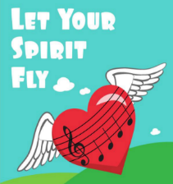What else have you Learned

|  |
| --- |
|  |
|  |
|  |
|  |
|  |
|  |
|  |
|  |

(optional)