 Cycle A Autumn Term Year 3/4 History Knowledge Organiser

(Sticky) Knowledge & Skills that I need to remember

|  |
| --- |
| * I understand that different civilizations were developing at the same time and where they first appeared. |
| * I can identify the major achievements of the Ancient Civilizations |
| * I can use images of artefacts |
| * I can say how pyramids could have been built using evidence. |
| * I can explain the greatest achievements of the Ancient Egyptians. |
| * I can learn about ancient beliefs in different civilizations |

|  |  |
| --- | --- |
| Key Vocabulary | |
| civilisation | a group of people with their own languages and way of life |
| dynasty | rulers who belong to the same royal family for generations. The term is also used to describe the era which that family ruled. |
| River valley | the natural channel/s which has/have been formed by a river. |
| irrigation | Irrigation is what farmers do when they add water to their fields. |
| achievements | Something achieved through hard work, courage or skill. |
| artefacts | a simple object (such as a tool or weapon) that was made by people in  the past. |
| settlement | Settlements are places where people live and sometimes work. |
| pyramids | A pyramid is a structure with four triangular sides. The pyramids were  built as tombs for the pharaohs. |
| beliefs | Is an idea that we hold as being correct |

Main Learning

**What do the 4 Ancient Civilisations have in common? How was Ancient Egypt similar or different to the other earliest cities?**

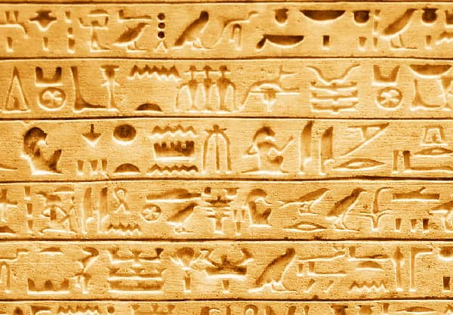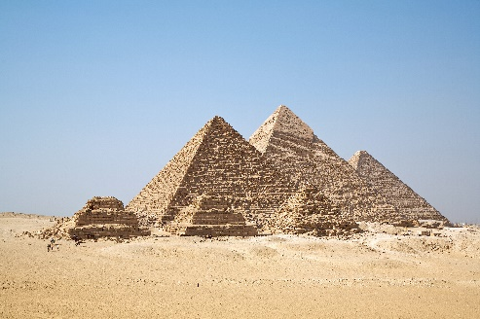

 History Quiz 1

Name ………………………….

|  |  |  |  |  |
| --- | --- | --- | --- | --- |
|  | **Question** | A | B | C |
| 1 | Approximately, when did the first civilisations appear? | 500 AD | 1000 BC | 3000 BC |
| 2 | Where did the first ancient civilisation first appear? | Egypt | Mesopotamia | Mexico |
| 3 | What is one major achievement of Ancient Sumer? | A ball | A computer | The Wheel |
| 4 | What is one major achievement of Ancient Egypt? | hieroglyphic writing | cars | books |
| 5 | What is one major achievement of Indus Valley? | sandstone | cities | buses |
| 6 | What is one major achievement of Shang Dynasty? | Organised government | Pyramids | hieroglyphics |
| 7 | Which is the tallest pyramid in Egypt? | Great Sphinx of Giza | The Great Pyramid of Giza | Red Pyramid |
| 8 | Which rivers did the Sumerians rely on? | The Tigris and Euphrates | The River Nile | The River Mersey and the River Tame |

Total

|  |  |  |  |
| --- | --- | --- | --- |
| Prior knowledge % | 1st Attempt % | 2nd attempt % | 3rd Attempt % |

What else have you Learned

|  |
| --- |
|  |
|  |
|  |
|  |
|  |
|  |
|  |
|  |

(optional)