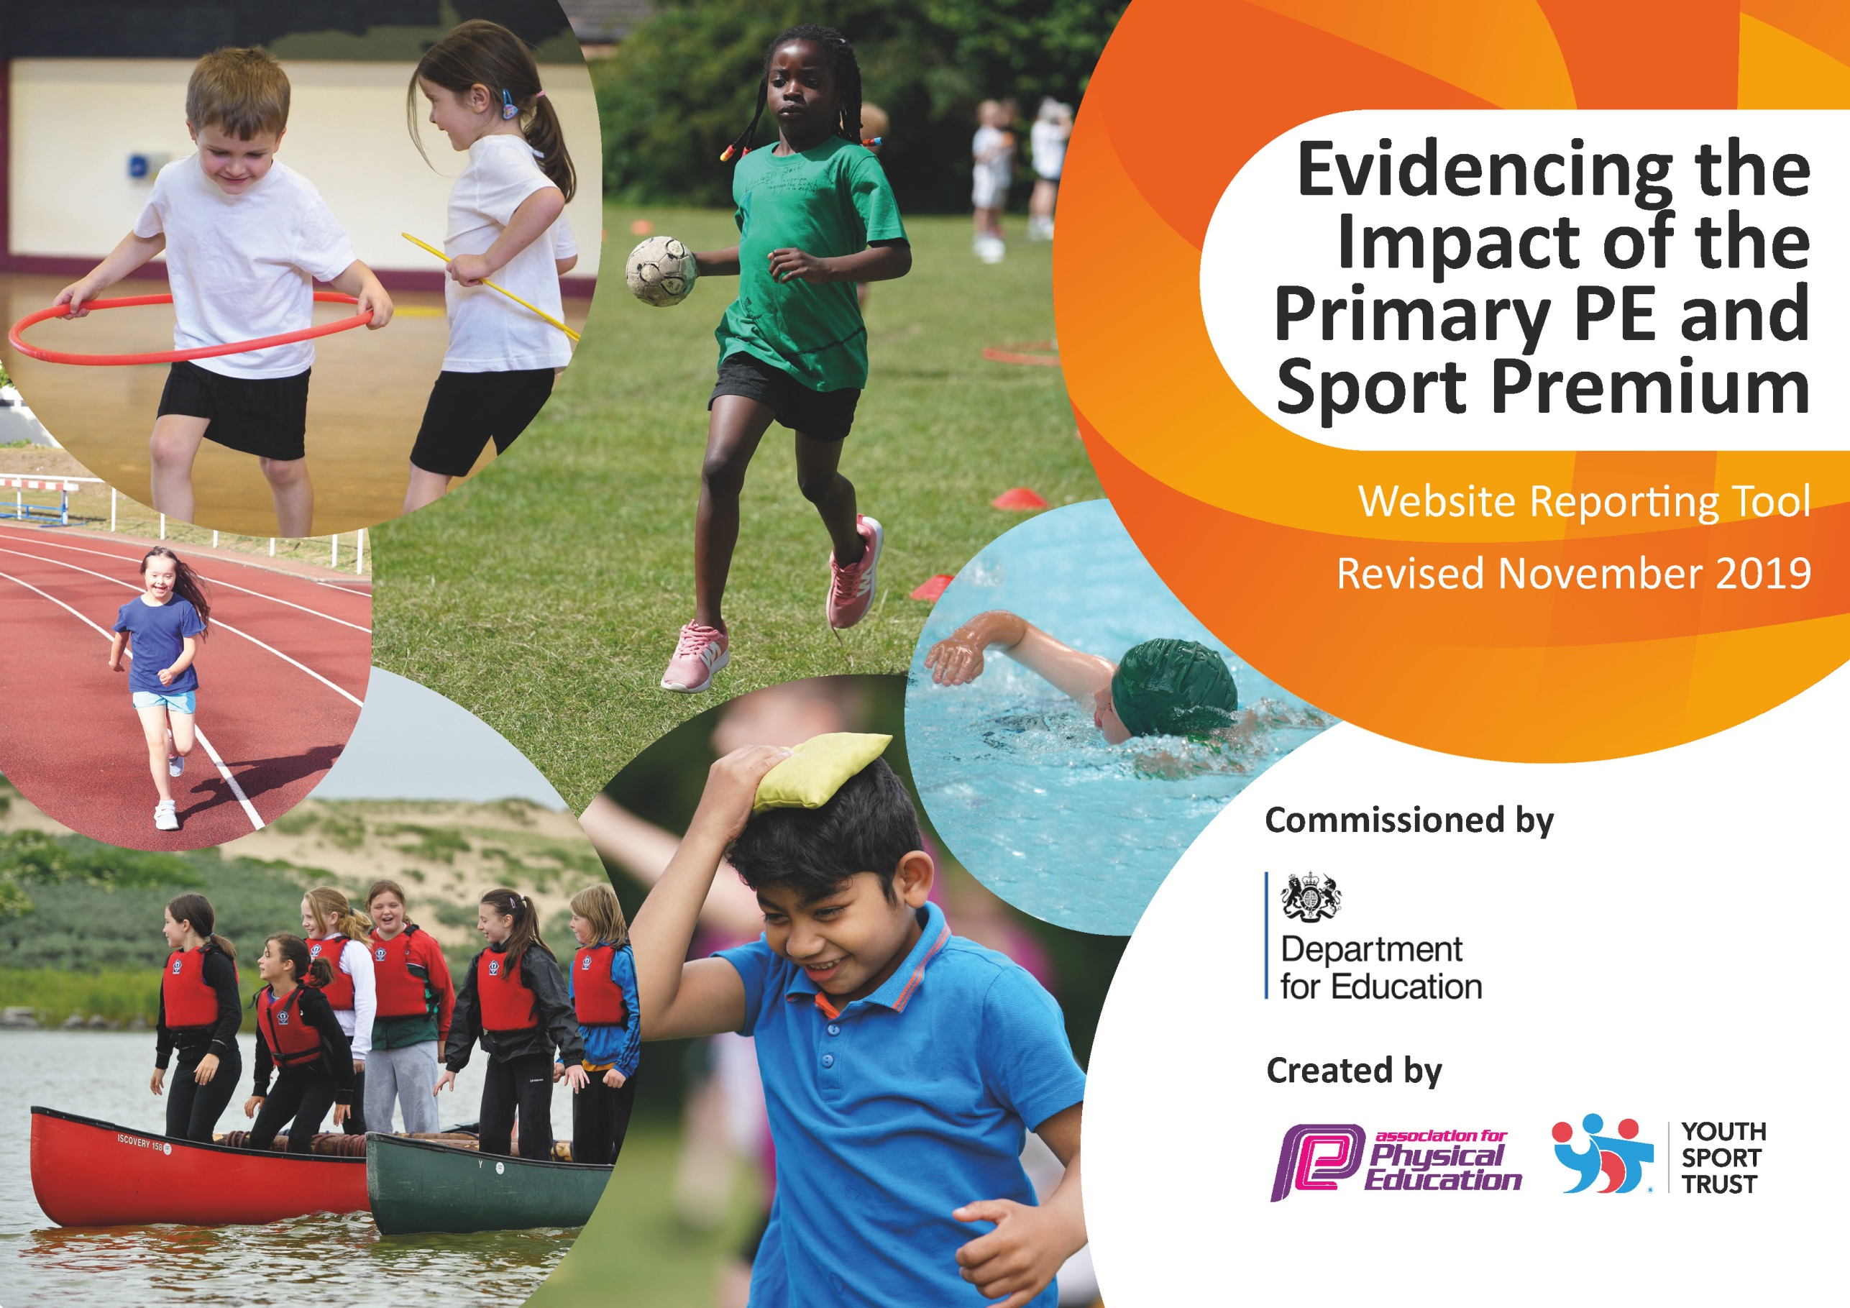
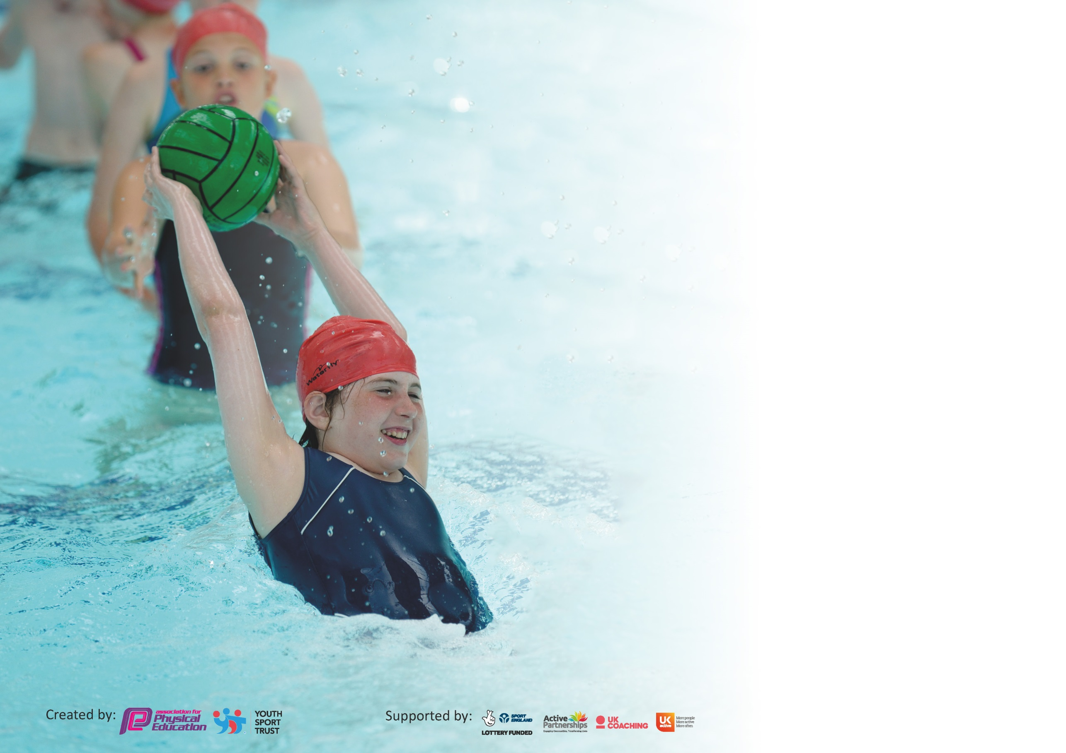

It is important that your grant is used effectively and based on school need. The Education Inspection Framework (Ofsted 2019 p64) makes clear there will be a focus on ‘whether leaders and those responsible for governors all understand their respective roles and perform these in a way that enhances the effectiveness of the school’.

Under the Quality of Education criteria (p41) inspectors consider the extent to which schools can articulate their curriculum (INTENT), construct their curriculum (IMPLEMENTATION) and demonstrate the outcomes which result (IMPACT).

To assist schools with common transferable language this template has been developed to utilise the same three headings which should make your plans easily transferable between working documents.

Schools must use the funding to make additional and sustainable improvements to the quality of Physical Education, School Sport and Physical Activity (PESSPA) they offer. This means that you should
use the Primary PE and Sport Premium to:

- Develop or add to the PESSPA activities that your school already offer
- Build capacity and capability within the school to ensure that improvements made now will benefit pupils joining the school in future years

Please visit gov.uk for the revised DfE guidance including the 5 key indicators across which schools should demonstrate an improvement. This document will help you to review your provision and to report your spend. DfE encourages schools to use this template as an effective way of meeting the reporting requirements of the Primary PE and Sport Premium.

We recommend you start by reflecting on the impact of current provision and reviewing the previous spend.

Schools are required to publish details of how they spend this funding as well as on the impact it has on pupils’ PE and sport participation and attainment by the end of the summer term or by 31st July 2021 at the latest.

We recommend regularly updating the table and publishing it on your website throughout the year. This evidences your ongoing self-evaluation of how you are using the funding to secure maximum, sustainable impact. Final copy must be posted on your website by the end of the academic year and no later than the 31st July 2020. To see an example of how to complete the table please click HERE.

Support for review and reflection - considering the 5 key indicators from DfE, what development needs are a priority for your setting and your pupils now and why? Use the space below to reflect on previous spend and key achievements and areas for development.

Key achievements to date until July 2022: | Areas for further improvement and baseline evidence of need:
Engagement of all pupils in regular physical activity:  • Ensured that greater than 80% of children are able to swim and/or self-rescue at the end of year 6.  • Increased numbers of pupils competing in games/competition at lunch times and play times.  • Sustained the number of days the daily Mile is completed across the school (every day Monday-Friday).  Consistent use of specialist PE staff within school to deliver a broad range of sports and lessons, e.g. dance, PE lessons and orienteering. | - To target more in school and inter school competitions, post-covid restrictions.  - To further raise attainment in primary school swimming to pass last year’s total of 80% of Year 6 children able to swim 25m.  - To improve subject knowledge and delivery of staff through CPD and use of an online assessment and lesson planning tool.

Meeting national curriculum requirements for swimming and water safety.
What percentage of your current Year 6 cohort swim competently, confidently and proficiently over a distance of at least 25 metres?  N.B. Even though your pupils may swim in another year please report on their attainment on leaving  primary school at the end of the summer term 2022. | 80%
What percentage of your current Year 6 cohort use a range of strokes effectively [for example, front crawl, backstroke and breaststroke]? | 80%
What percentage of your current Year 6 cohort perform safe self-rescue in different water-based situations? | 93%
Schools can choose to use the Primary PE and Sport Premium to provide additional provision for swimming but this must be for activity over and above the national curriculum requirements. Have you used it in this way? | Yes – additional swimming time was allocated for Y6, Y5, Y4 and Y3 children across the school year.

Action Plan and Budget Tracking
Capture your intended annual spend against the 5 key indicators. Clarify the success criteria and evidence of impact that you intend to measure to evaluate for pupils today and for the future.

Academic Year: 2021/22 | Total fund allocated: £16910 | Date Updated: 31st July 2022
Key indicator 1: The engagement of all pupils in regular physical activity – Chief Medical Officer guidelines recommend that primary school pupils undertake at least 30 minutes of physical activity a day in school |  |  |  | Percentage of total allocation:
 |  |  |  | 57%
Intent | Implementation |  | Impact
Your school focus should be clear what you want the pupils to know and be able to do and about  what they need to learn and to  consolidate through practice: | Make sure your actions to achieve are linked to your intentions: | Funding allocated: | Evidence of impact: what do pupils now know and what can they now do? What has changed?: | Sustainability and suggested next steps:
To sustain the incidences of the Daily Mile, to expand opportunities for directed, sustained physical activity at play times and lunch times.  To develop the profile of the playground and field area. | Sustained opportunities to do the daily mile each afternoon.  Development of the playground with markings for the Daily Mile, interactive physical challenges and number jumping games.  Adventure playground including rope bridges, balances and climbing tyres. | £3700  (Playground markings)  £5900  (Adventure playground) | Resources purchased add to a higher quality activity and physical experience.  Children not participating in regular sport activity during play times have now taken an interest and increased their levels of physical activity.  Age and stage appropriate equipment has increased pupil engagement during play times, lunch times and after school clubs.  Daily Mile participation has increased and has been sustained. | To continue to develop the impact of play leaders to increase participation in physical activity of KS1 and lower KS2 pupils.  Extend the use of equipment to after school clubs and develop the extra-curricular programme.
Key indicator 2: The profile of PESSPA being raised across the school as a tool for whole school improvement |  |  |  | Percentage of total allocation:
 |  |  |  | 11%
Intent | Implementation |  | Impact
Your school focus should be clear what you want the pupils to know and be able to do and about  what they need to learn and to  consolidate through practice: | Make sure your actions to achieve are linked to your intentions: | Funding allocated: | Evidence of impact: what do pupils now know and what can they now do? What has changed?: | Sustainability and suggested next steps:
Raising the profile and quality of P.E. / sport by securing increased participation and achievement through high standards. | Purchase of spare PE kit including t-shirts, shorts and footwear for all key stages.  Specialist in-school staff member to teach all classes each week; Active PE and Sport and wellbeing activities linked to reading and awareness.  CPD for staff based on curriculum and wellbeing awareness. | £220  (PE t-shirts, shorts and footwear)  £1700  (In-school staff member teaching PE and Wellbeing – arrangement altered from March 2022 – Year cost would have been approximately £4000) | Each class to have a storage unit of spare kit available at hand to use when necessary.  Staff member ready to begin targeted teaching in KS1 and KS2 classes in September. | New approach in timetable will continue to develop the pupils understanding of a healthy lifestyle and PE and sport.

Key indicator 3: Increased confidence, knowledge and skills of all staff in teaching PE and sport |  |  |  |  |  |  | Percentage of total allocation:
 |  |  |  |  |  |  | 4%
Intent | Implementation |  |  | Impact
Your school focus should be clear | Make sure your actions to |  | Funding | Evidence of impact: what do |  |  | Sustainability and suggested
what you want the pupils to know | achieve are linked to your |  | allocated: | pupils now know and what |  |  | next steps:
and be able to do and about | intentions: |  |  | can they now do? What has
what they need to learn and to |  |  |  | changed?:
consolidate through practice:
Raising teaching competencies and leadership in P.E. / sport via high quality professional development for teachers, Classroom Assistants and Mid-Day Assistants. | Attendance at CPD events to develop increased expertise in the area of P.E. Training for Midday assistants.  PE lead to administer CPD to staff on approach to lessons and developments to increase physical activity in pupils. |  | £600  (Specialist staff attendance and delivering of CPD to staff) | PE curriculum grew in quality and consistency with pupils and teacher’s competency improving.  Teacher assessment showing an increase in pupil’s physical activity levels.  When staff changes in March meant that the original specialist staff member was no longer present during lessons, children and staff were more confident in set processes and expectations of participating in and delivering high quality PE. |  |  | Staff and pupil questionnaires  Development of lunchtime and after school extra-curricular activities led by staff.  Bespoke CPD for staff
Key indicator 4: Broader experience of a range of sports and activities offered to all pupils |  |  |  |  |  |  | Percentage of total allocation:
 |  |  |  |  |  |  | 20%
Intent | Implementation |  |  | Impact
Your school focus should be clear | Make sure your actions to |  | Funding | Evidence of impact: what do |  |  | Sustainability and suggested
what you want the pupils to know | achieve are linked to your |  | allocated: | pupils now know and what |  |  | next steps:
and be able to do and about | intentions: |  |  | can they now do? What has
what they need to learn and to |  |  |  | changed?:
consolidate through practice:
Additional achievements: Increasing the range of opportunity available in PE / sport by hiring specialist PE practitioners to work alongside staff when teaching P.E.  E.g. Dance specialist from ACTC to teach across both key stages during two afternoons  Support for transport and funding for overnight camping and outdoor adventure day at school in June.  To recapture opportunities for swimming lost during lockdown and precautionary periods in previous years. | Equipment purchased to broaden the range of sports provided by school; Football, indoor games, tennis, archery, tri-golf, skipping ropes and balance equipment, multi-skills for KS1 and Reception.  Transport and costs for swimming to compensate for lost sessions during lockdowns. (KS2) |  | £1600  (Dance specialist)  £630  (equipment)  £1220  (28% of transport and swimming costs)  (Overall transport and swimming costs £4350) | Children experienced a broader range of sporting opportunity that has visibly increased their physical activity and levels of enjoyment.  Children demonstrated improving levels of motivation, effort and enjoyment and a new motivation through exciting dance lessons.  Comprehensive package of swimming lessons has rebuilt confidence of all year groups and the targets set for Y6 have been achieved. Many Y3/4 had their first experiences of going into a swimming pool which helped their confidence grow before their ‘normal’ opportunities in Y5. |  |  | Termly pupil and staff questionnaires to determine the impact each sport has had on the pupils.  Identify skills developed by the children and extend those through participation in various sports, e.g. dance to gymnastics.  Identify and target clubs and activities going forward.
Key indicator 5: Increased participation in competitive sport |  |  |  |  |  | Percentage of total allocation:
 |  |  |  |  |  | 8%
Intent |  | Implementation |  |  | Impact
Your school focus should be clear |  | Make sure your actions to | Funding |  | Evidence of impact: what do | Sustainability and suggested
what you want the pupils to know |  | achieve are linked to your | allocated: |  | pupils now know and what | next steps:
and be able to do and about |  | intentions: |  |  | can they now do? What has
what they need to learn and to |  |  |  |  | changed?:
consolidate through practice:
To increase the number of pupils regularly attending enrichment activity – for example WPSSA interschool competitions and School Games. Increased opportunity will improve pupils motivation and social interaction.  Expand the profile and focus of sports day to bring Rec/KS1 and KS2 opportunities to participate in competitive sports in front of parents. |  | Membership fees, affiliation and entry fees to a range of competitions and events. Increasing opportunity via attendance at inter-school competition. Bus hire for attending. Supply cover to free travelling staff.  Providing rewards for participation and for achievement with medals and prizes along with the spectacle of a Commonwealth Games format including focus on British Values and countries linked to the Commonwealth. | £220  (Transport costs – coaches and taxi use to events)  £500  (Halton Games membership)  £450  (Supply Costs)  £166  (Medals, flags and flag poles) |  | Inter and intra competition opportunities with Halton Games and St. Chads.  Intra-school competition has continued until inter competitions were more readily available.  The Holy Spirit Commonwealth games had the largest attendance of any school event this year. It also had the largest number of children in a voluntarily, competitive setting. | Develop opportunities for Intra school competition in both KS1 and KS2 and to celebrate these via media platforms and reward within school.  Use and monitor registers for clubs and competitions to gain data for the year and use this moving forward.

Signed off by
Head Teacher: | Lorraine Connolly
Date: | 31st July 2022
Subject Leader: | Paul Foster
Date: | 31st July 2022
Governor: | Kathy Keig
Date: | 31st July 2022

