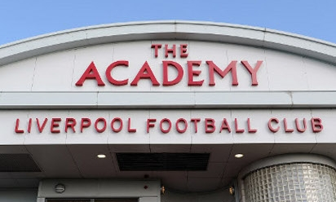
Liverpool Football Academy
Multi-skills day

Date: 16th Jan 2020
Dear parents/carers,
We are very pleased to inform you that our Reception children have been invited to take part in a Multi-skills session at the Liverpool Football Club Academy on Friday, 14th February 2020. The day will be a caracal full of football based games, ran by LFC and their partners. It promises to be a fun day with lots of activities, during which the hosts will also be trying to talent spot.
We are very excited about the visit and we are limited to take up to 12 children, so if you would like your child to take part, please fill in the reply slip below and return to school ASAP but no later than Monday, 10th Feb 2020. We will choose the children on a first come-first serve basis and out of a hat.
The session will start at 12.30 pm (we will have an early lunch in school), and will finish at 2.30 pm, so we should be back to school for 3 pm.
Children will need to bring a water bottle, a pair of trainers, a football kit or track suit bottoms and top, as well as football boots, as they are likely to be playing outside.
Best wishes,
Mrs Crabbe

Please return the slip no later than Monday, 10th February 2020.
I would like my child …………………………………….. to take part in the Multi-skills session at the Liverpool Football Club Academy on Friday, 14th February 2020.

Signed …………………………... Relationship to the child ……………………….

