Tuesday, 28 July 2026

Dear Parents/Guardians,

Halton Borough has advised schools of the following; unfortunately following on from yesterday’s email, we have had another report of another child at a different Widnes school being followed on their journey to school this morning. This male was also dressed in black and was wearing a black hat covering his nose and face (possibly a balaclava). Police have been informed.

We would like to ask all parents and children to be vigilant.

Yours sincerely,
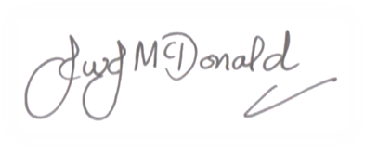

John McDonald
Headteacher

