We belong to the
Parish of Maximillian Kolbe.
Our priest is Fr. Peter.

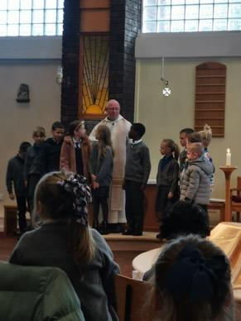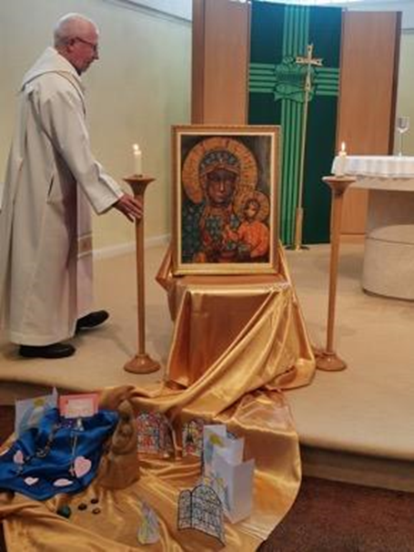

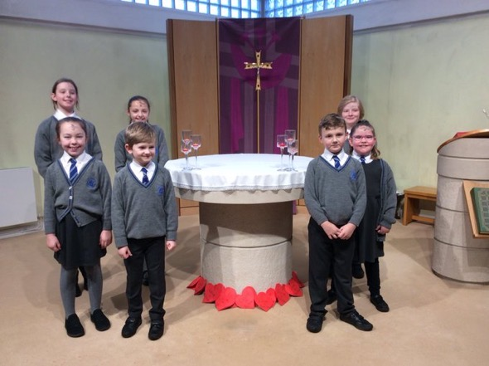
Ash Wednesday Service –
Mini Vinnies

