All Are Welcome
Children learn about Judaism in KS 2 as part of the RE curriculum.
Little Diamonds learn about other faiths in ‘knowledge and understanding of the world’.
We want every child to feel welcome and that their beliefs are respected.
Muslim parents have visited classes to talk about Islam.
Muslim children have told us they feel comfortable in school.
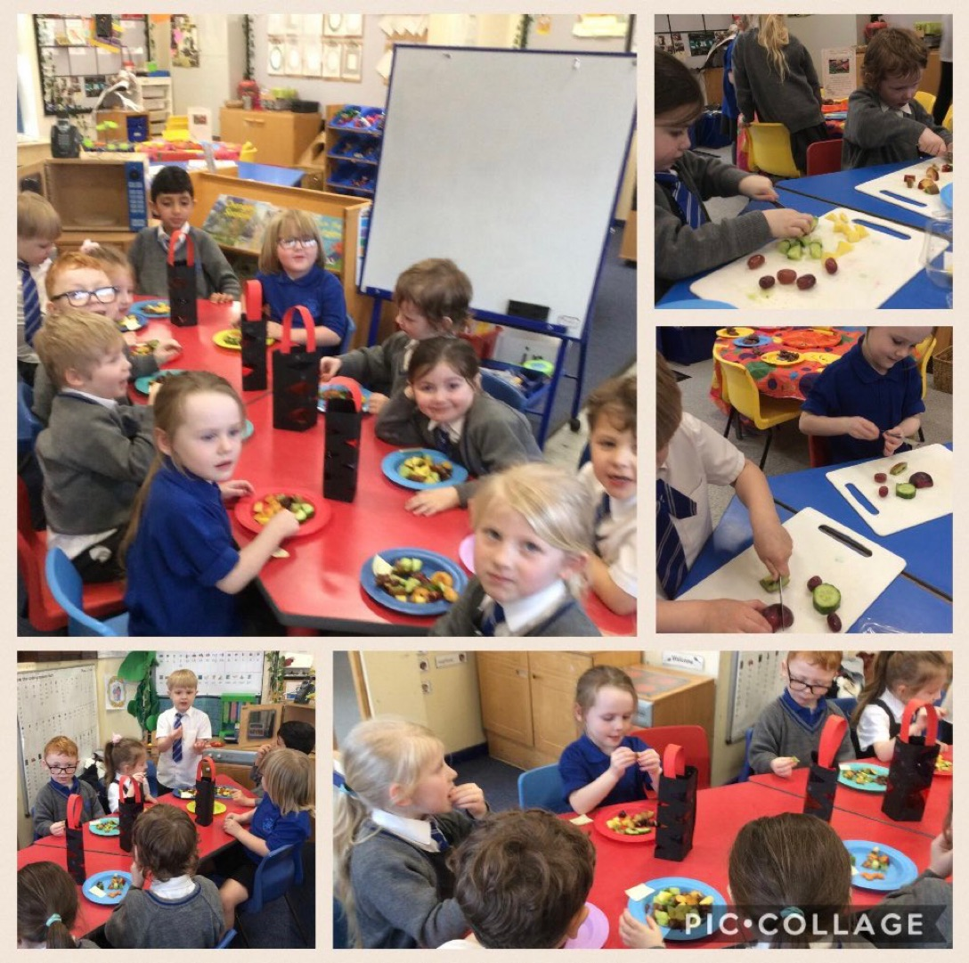

Food for Eid

Children often answer the register in other languages
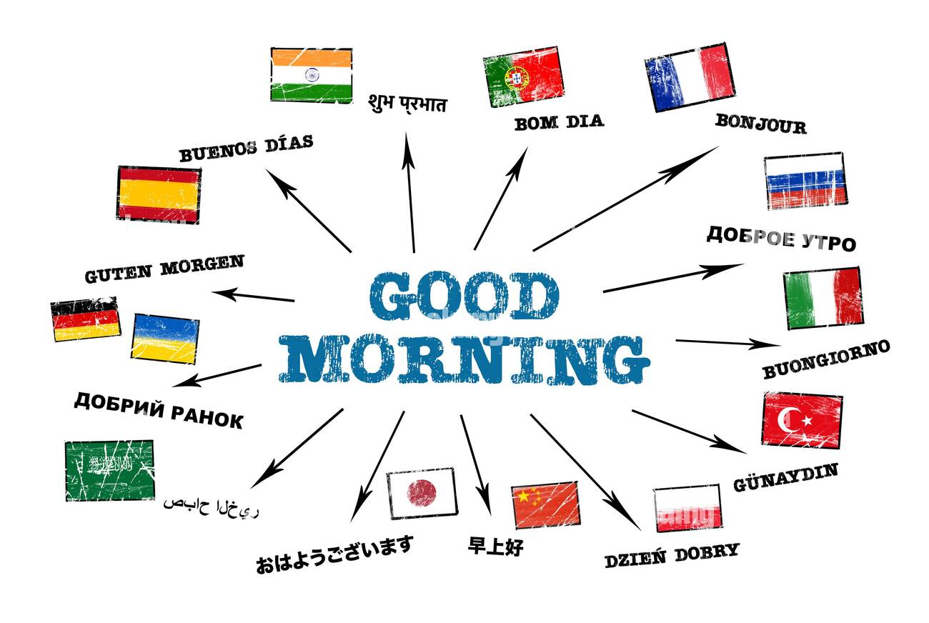

Divali

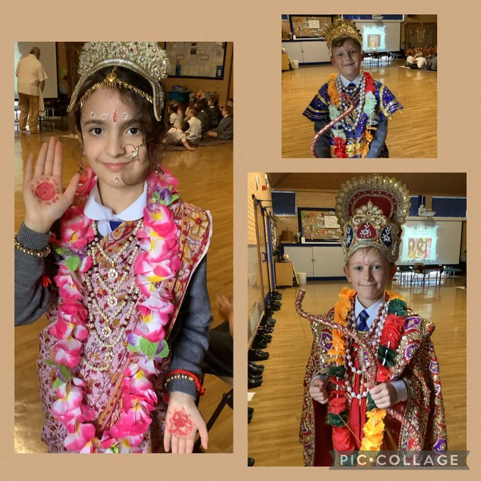

Making Divali Lamps
