18 June 2021

Dear Colleague,

This week, the Government delayed the full lifting of restrictions as COVID-19 case numbers continued to rise, particularly in the North West.
Halton was named as an Enhanced Support Area where the Delta variant is spreading fastest we therefore have to put additional measures in place.
Residents are advised to minimise travel in and out of Enhanced Support Areas (https://www.gov.uk/guidance/covid-19-coronavirus-restrictions-what-you-can-and-cannot-do). As part of this, our area has been given an additional support package to help control the spread of COVID-19.
We are seeing high numbers of COVID-19 cases in our education settings, and several schools have had outbreaks in recent weeks.
I have reviewed our position with our education team and worked with other Directors of Public Health across Cheshire and Merseyside to determine the most appropriate advice to issue to our schools and college.
Face coverings
In schools where pupils in year 7 and above are educated, face coverings should be worn by adults and pupils when moving around the premises, outside of classrooms, such as in corridors and communal areas where social distancing cannot easily be maintained.
I do not currently advise the use of face coverings in the classroom but will continue to review this in light of our case numbers and any evidence of transmission in school settings.
In primary schools, face coverings should be worn by staff and adult visitors in situations where social distancing between adults is not possible (for example, when moving around in corridors and communal areas). Children in primary school do not need to wear a face covering.
Sporting events
I do not advise that sports events take place between different schools this summer term. This includes matches between teams.
School sports events within a single school can take place outside within bubbles NOT mixed bubbles.
School Sports Days should not allow spectators to attend. Nor should bubbles mix. And a risk assessment should be undertaken.
School trips
I advise that school trips do not take place this summer. This includes both indoor and outdoor venues in Halton and in other areas across the North West and beyond.
Residential trips
I advise against any residential trips this summer term.

Transition arrangements
I advise that usual transition visits do not take place from early years to primary schools, from primary to secondary schools and from secondary to college. Virtual arrangements should be considered where practicable. Where visits are being offered, these need to be risk assessed and monitored, children should remain in their bubbles and these visits should occur outside of usual school opening hours to minimize risk.
Where children have specific vulnerabilities and a visit is required, these should be risk assessed, with additional measures put in place. Vulnerable children should ideally visit individually where possible or remain in their bubbles if not possible. .
Leavers’ events
Events in primary schools should remain on site and not allow visitors. Children should remain within their bubbles.
I advise that events in secondary schools be delayed until after restrictions are fully lifted – currently scheduled for 19th July 2021 but subject to change. Where on site events are planned, such as special assemblies, I advise that bubbles are not allowed to mix.
I understand that this advice will lead to disappointment and will be difficult for some but I believe it gives us the best chance of controlling our rising case numbers and returning to some normality during the next school year.
Other important measures
- Rapid lateral flow testing is still important for picking up cases of COVID-19, but we need people who test positive or have symptoms to get a PCR test (that is sent to the lab for processing).
- I have been advised by Public Health England that we no longer need to request PCR testing of all contacts for single cases. However, my team will continue to recommend testing of contacts when two or more cases occur in the same bubble – please seek advice.
- While the roll-out of the vaccines is progressing well, many of our education staff and parents still will not have received both doses of their vaccination. All adults are now eligible so please encourage staff and parents to take up this offer.
- Follow national advice and restrictions around mixing with others and do this as safely as possible. Meeting outside is still safest.
- Continue twice weekly rapid testing for COVID-19. This is for families, staff and secondary school and college students. We are working with secondary schools to develop on site testing for the remainder of the term. Parents of primary aged children may also choose for their children to participate in these tests using our test centres or home tests. Additional information can be found here: No symptoms COVID-19 testing (halton.gov.uk)
- Anyone with a positive rapid lateral flow test should self-isolate with their household and get a PCR test (that is sent to the lab) to confirm the result. These must be booked online at https://www.gov.uk/get-coronavirus-test
- Testing results should be reported via the NHS online reporting system. Results should also be reported to school (schools may have their own systems in place for reporting results).
- Schools should continue to report all positive cases (both rapid lateral flow tests and PCR tests) to Ann McIntyre (ann.mcintyre@halton.gov.uk ) and to the public health team (public.health@halton.gov.uk ).
- Remember that if you (or your child) have been in contact with someone with COVID-19, you will need to isolate for ten days, regardless of any test results you might get.

Many thanks for your understanding.

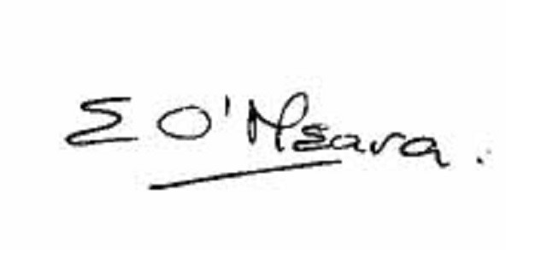

Eileen O’Meara, Director of Public Health and Health Protection
Halton Borough Council

